2017 MARCH MAILING

To: Unit Presidents District Chairmen
Department Chairmen/Committees Department Executive Committee
Hospital Representatives/Deputies Past Department Presidents

PLEASE OPEN AND READ THRU THIS MAILING. IT CONTAINS IMPORTANT DOCUMENTS.
This mailing contains the 2017 District Summer Call To Convention and other valuable information. Please share the following with all members:

- District Call To Convention (white envelope) – all members
  - District Summer Convention Call (white)
District Call
To Convention
Documents
  - Convention Representation By Units (white)
  - Delegates-At-Large per District (pink)
  - Department and District Convention Delegate Certification Form (2) (blue)
  - Department and District Convention Alternate Certification Form (2) (yellow)
  - District Convention Alternate to Delegate Certification (white)

Also included in the mailing is the NEW Officer Certification FORM. Please adhere to the deadlines and turn these forms in by the due date as not doing so could have major repercussions to you Unit.

- Message from President Denise Conrad – all members
- Membership (yellow) −Membership Cha0irman and all members
- THE SOS (ivory) – all members
- Americanism (grey) – Chairman
- Community Service (yellow) - Chairman
- Constitution & Bylaws (ivory) – Unit Officers
- Leadership (salmon) – Chairman
- Legislative (buff) – Legislative Chairman
- VA&R (white) – all members
- Veterans Memorial Pamphlet- In Memory Form for those that have passes as a result of the War
- Department Program Report Form Directions
- National Unit Impact Report Form Directions

- Certificate of Unit Officers For 2017-2018 (ivory) Unit Secretary & President - Deadline June 1st, 2017

TO FILE YOUR 990EZ ONLINE
Make this a part of your Treasurer’s
April/May Report
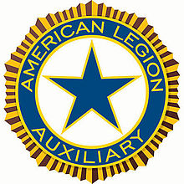
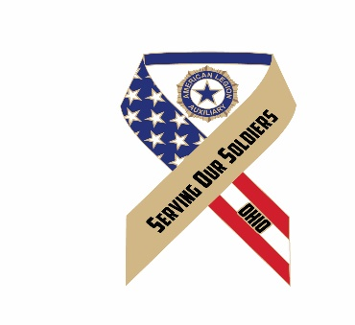

Denise Conrad
Department President
1108 Erie Ct.
Woodville, Oh 43469
dconrad0609@gmail.com
March Bulk Mail

Dear Unit Members,

Another month has gone by and we are getting closer to our reporting deadlines. Please check the Plan Of Actions to make sure you are sending your Reports and Unit Narratives to the correct person. Americanism, Children & Youth, Community Service, Junior Activities and VA&R are all to be sent to the District Chairman in your District.

The National Impact Report is due by the Unit to the District President by May 1. This is the only report that is MANDATORY. I cannot stress enough the importance of this report. It is a total of all the hours, donations, volunteers, etc. from all programs that your Unit promoted. The Unit Impact Report is sent to the District President. The District Impact Report is then completed and sent to the Department Secretary. Katie then totals the District Reports for the entire Department and sends the report to the National Organization so National can account for all the good work we do in our Departments across the Nation.

I hope many of you have the Poppy Shop Open House at the Ohio Veterans Home in Sandusky on your agenda for April 2. It will be great to recognize the Veterans who so diligently make all of our Ohio poppies. Our Miss Poppy Parade is also very impressive. Please be sure to have your Miss Poppy reservations made by March 25 deadline to Patricia Taylor, Poppy Chairman.

Please plan to have a donation or fund raiser at your District Summer Convention for the Military Family Assistance Fund. Your efforts are greatly appreciated.

Hugs to All,

Denise

MEMBERSHIP
Shirley Maurer, Chairman

I know I sound like a broken record and you get tired of hearing this, but I can’t stress enough our membership. As of this past week, we are still over 1300 renewals down from last year at this time. Some weeks we gain ground and the next week we lose ground. We have to realize that our membership is our life blood if we want to continue with our programs. Without our membership, our programs are going to suffer and I really don’t want to see that happen. We do such good things for our veterans and they deserve our support. Just think what it would be like if our veterans did not protect our country. Things would be completely different today.

As of our last membership report of March 10th, we have 38 goal units. CONGRATULATIONS TO THEM. But that is only 9% out of 403 units. There are many units that need under 10 renewals to make goal. Each district president received a list of names that formerly belonged to a unit. Surely you can find several on there that would like to rejoin. Please give it a try. You may be surprised how many will want to re-join.

As our membership year will soon be coming to a close, we need to think about the awards that are available to apply for. Following is a list of the awards. I hope each unit will apply for these awards.

Following is a list of the National Awards that you can apply for. The criteria for these awards are found in your Membership Plan of Action. These awards are all due to National Headquarters by May 1st.
- Member Award: Rejoin 1
- Member Award: Recruit 1
- Member Award: Recruit 10
- Member Award: Silver Brigade
- Unit Award: Best Member Experience (This one is due to me by April 15th)

Department Membership Unit Awards are due to me no later than April 15th and they are as follows:
- Jane Bates Membership Plaque – Unit with the highest numerical increase over goal.
- Patricia Riley Membership Plaque – Unit with the second highest numerical increase over goal.
- Doloris Kilgore Membership Plaque: Unit with the highest percentage of membership over goal.
- Jackie Bayer Membership Plaque: Unit with the most new members per capita. (New members divided by goal---New units will use the number of charter members, all other units will use 2016-2017 goal)

I still have three (3) incentives to give out yet and they are as follows:
- Incentive #3 - $5 to the unit with the greatest increase of Junior members from April 1, 2016 to March 31, 2017, to be given at Junior Convention.
- Incentive #4 – (FOR DISTRICT PRESIDENTS) - $100 TO THE District President that transfers the most members out of 888, with verification, by May 31, 2017. To be given at Department Convention.
- Incentive #6 – For all goal units by June 1, 2017, a drawing will be held at Department Convention. Three units will be drawn with the first drawn receiving $100; second one drawn receiving $50; and the third one drawn receiving $25.

LASTLY, I have a year end report that is due to National and need your help. Please either send me or e-mail me what your unit has done to increase membership. The following questions may help you answer my questions.
- As the unit membership chairman, how have you disseminated information to your units?
- What did you do to encourage membership?
- What were your successes throughout the year?
- What were some of your hurdles/difficulties faced during this year?

You may also send me pictures showing how you recruited, renewed and retained membership.

Let’s have a great remainder of the year and I look forward to getting your reports.

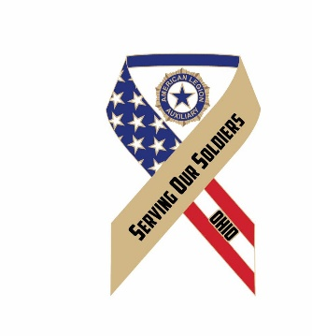 THE SOS 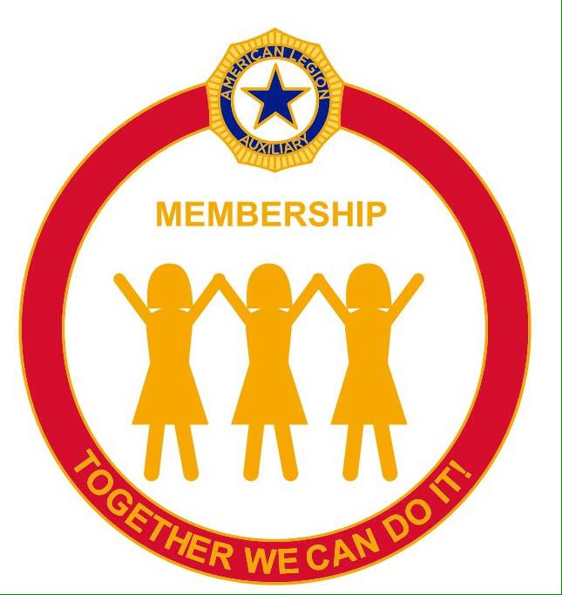
Serving Our Soldiers Sharing Our Stories Together We Can Do IT
Editor: Kathy Heichel__________________________

Well here we are coming to the time to do those green reports. Most of them have a deadline date of April 15th which means you’re going to be very busy getting all your information together and filling them out. Remember that all zeros do not count as a report so don’t waist a stamp mailing it if that is the case. Which I cannot imagine that nothing was done as busy I know you all are. Do not forget your 25 cents per paid member on Children and Youth and 75 cents per paid member on V.A.&R. Look for your Chairman’s name and address on front of report and mail to the right person on time. Some reports go to your District chairmen first before going to Department. I know all would love to have 100% reporting and we can do it. Please send your news articles, flyers, bulletins anything you have done to me for Public Relations so I can report to National just how busy Ohio has been and make President Denise’s Press Book outstanding.
Here is a sample of one unit who has Walked the Walk and Talked the Talk.
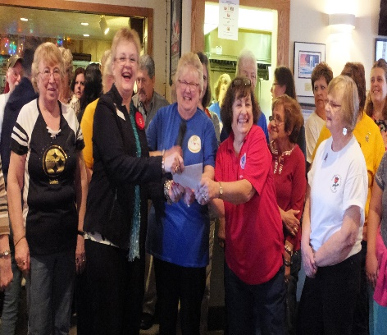

Members of Unit 214, Willoughby, presenting check for President Denise’s Special Project Military Family Assistance Fund. Money raised at annual soup night.
And how about this they have a radio show how great is that!

The name of show is “They Sacrificed for Us”
Here is Martha Setlock and President Denise with Host Bob and Sue Fratino. Way to go Unit 214!!

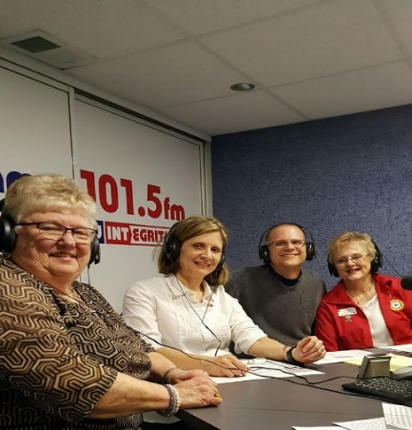

DATES TO REMEMBER
APRIL
1st Junior Conference
1st DEC Meeting
2nd Poppy Shop
14th Good Friday
15th Bulk Mail Due
And reports should have already been mailed.
16th Easter

AMERICANISM

The most recent budget analysis received from Department shows we are far behind projected receipts for both Spirit of Youth and the A&G test trip; both are very important elements of the Americanism program. Your donations are very much needed and appreciated.
The year-end reports will soon be due and what better way to communicate all you have done throughout the year. The reports are so important in many ways and are not difficult or time consuming to complete. National and Department have worked very hard to simplify them without losing valuable information. So please, complete them and get them submitted by the deadline. Every Unit should have done something related to Americanism; be proud of your work and anxious to report it! The Action Plan provides the information to guide you. Reach out if you need assistance. Our reports do make an impact on the state and national level; your Unit report is a wonderful example of who you are and what you have done.
Do you know about the Spirit of America’s Story – The Wall?” This is a 70 ft. traveling exhibit of images spanning the life of America from the Revolutionary War to the Persian Gulf War? Military men and women, law enforcement, firefighters, American Indians and others are portrayed in images to “keep America’s sense of patriotism ignited,” to promote respect for all in uniforms and bring people together for the love of our country. This Wall was created by Ohio Legionnaire Ron Smith (Post 83, Sandusky) and the widow of Army Sgt. David Sexton who was killed in the Vietnam War; his remains are yet to be returned. For addition information, go to their website: www.spiritofamericasstory.com
As citizens of this wonderful country and members of the American Legion Auxiliary, I think we all feel that every day is Americanism day. How we all enjoy the many freedoms we have because of the principles upon which our country was founded. And lest we forget, our military who have and continue to protect them! THE ALA is the largest female patriotic organization and the finest example of Americanism. We stand united and are prime role models for what is proper and respectful! The American Legion
Auxiliary -what an impact we have on our veterans, military, youth, and communities; we are proud and stand strong-it is what is right about being an American!!
God Bless and thank you for all you do. It is all appreciated so much by many!!

Carole Sowards, Americanism Chairman

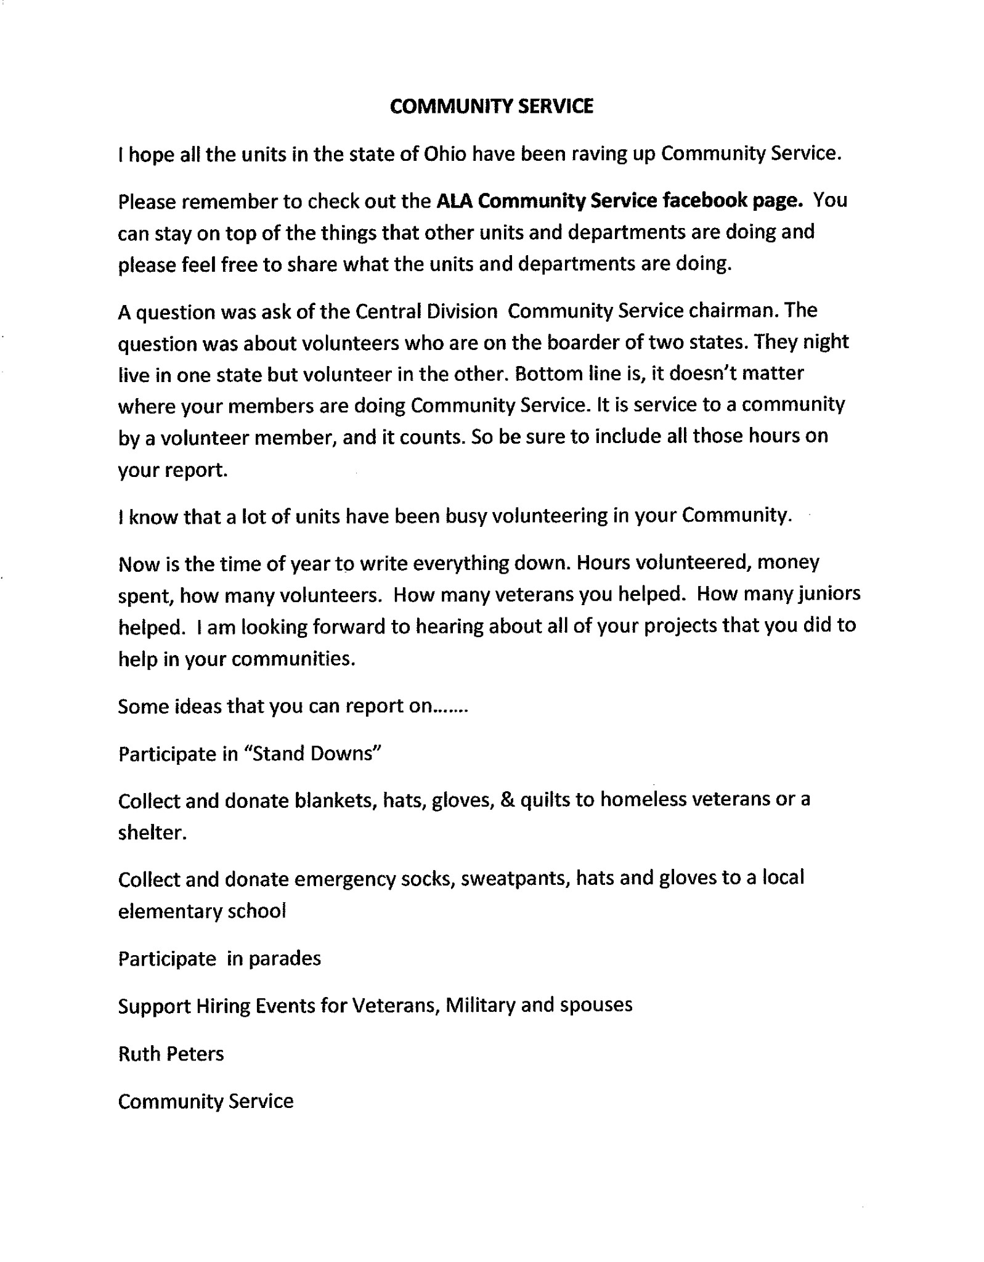

Pam Bates, Department of Ohio Leadership Chairman
2122 Willow Run Circle; Enon, OH 45323; 937-974-2316
pamelabates9@gmail.com (preferred communication)

TALK THE TALK…WALK THE WALK

The following information was on the National website www.alaforveterans.org. The Ohio Program of Action for Leadership can be found at www.alaohio.org. At both websites, you will find many tools to help seasoned and new members understand “WHO WE ARE AND WHAT WE DO”. Please take the time to research and read this information. The detailed information below go to www.alaforveterans.org/Members/ALA-Department-and-Unit-Resources/.
If you are not computer savvy…go to your local library, ask a friend or relative to help you download information.
CONFLICT MANAGEMENT
Conflict management is the process of planning to avoid conflict where possible and organizing to resolve conflict as rapidly and smoothly as possible.

Getting Along To Achieve Goals Effectively and Efficiently Auxiliary Need to:
- Share a vision of what they are striving to achieve
- Set clear objectives for each program committee
- Recognize & resolve conflict among members before conflict becomes a serious problem

Managing Conflict Is Never Easy
- Conflict involves members’ needs, their perceptions of reality, power, values, feelings and emotions
- Members need to have ways of keeping conflict to a minimum.

Common Causes of Conflict
• Different attitudes, values or perceptions
• Disagreements about needs, goals, priorities and interests
• Poor communication or inadequate organizational structure
• Lack of teamwork
• Lack of clarity in roles and responsibilities
• Desire for power

Signs of Conflict between Individuals
• Negative/hostile body language
• Members not speaking to each other and members ignoring each other
• Members contradicting and/or bad-mouthing each other & deliberately undermining or not
cooperating with each other

Conflict-prone Personalities
- Sherman Tanks — They try to intimidate with “in your face” arguments and state their opinion as fact.
  - Get their attention by beginning a sentence with their first name.
  - Maintain eye contact and give them time to wind down.
  - Stand up to them without being aggressive.
  - If they try to physically intimidate, suggest that you both sit down to continue the discussion.
- Snipers — They make snide comments in meetings and avoid one-on-one confrontations.
- Expose the attack.
- Draw them out and address their concerns in public.
- Get other opinions.
- Don’t give in to the sniper’s views.
- Chronic Complainers – They find fault with everyone except themselves.
- Politely interrupt and take control of the situation.
- Quickly sum up the facts and fight them with logic.
- Ask for their complaints in writing.
- Negativists – They believe that nothing new works. They will toss a wet blanket on your ideas.
- Acknowledge their valid points.
- Describe past successes of new ideas.
- Avoid the “You’re wrong; I’m right” approach.
- Exploders – They throw tantrums and escalate situations quickly into conflict.
- Give them time to regain self-control.
- If they don’t regain control, firmly state a neutral phrase such as “STOP.”
- • Take a time out or have a private meeting with them.

How to Build Teamwork and Cooperation
- Share information by keeping members up-to-date with current issues
- Express positive expectations about each other
- Empower each other by publicly crediting and encouraging members who have performed well and encouraging each other to achieve results
- Team-build by promoting good morale and protecting the group’s reputation
- Resolve potential conflict by airing differences of opinion and facilitating conflict resolution

Methods for Managing and Resolving Conflicts
- Conflict Buster Conciliation
- Negotiation
- Mediation
- Arbitration
LEADERSHIP

Goodwill
Compromise
Win-Win
Agree to Disagree

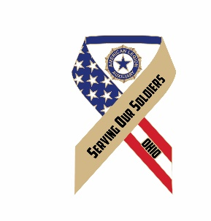
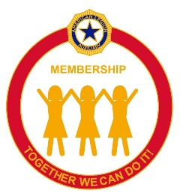
Veteran's Affairs and Rehabilitation
March

April is the Month of the Military Child. It is a good time to start a project, if you have not done so yet, to support the military children who have trouble with separation from their parent or dealing with frequent moves. Our national website alaforveterans.org. has the ALA Military Family Readiness Action Guide under the “members only” section. This is where you can find military families in need of assistance.

Summit for Soldiers is a group dedicated to helping veterans cope with suicidal thoughts and attempts. They are looking for veterans to help and donations to help promote their activities. They are holding two big events this month.
Saturday, March 18th Highpoint Academy, Bellefountaine. They will gather in the school auditorium from 10am to noon. They will have some interesting presentations and are inviting any organization to set up a table with their resources. Mike will be giving his presentation “Mt Everest: from Suicide to Summit”. At noon they will walk to the actual state high point to gather in solidarity, support and commitment to eradicate veteran suicide. All veterans and service members will be invited to sign the National Banner as a personal commitment to help eliminate the stigma and to reach out to one another when needed. The goal is 8000 signatures across the country and to connect all of them to their local resources. This is a free event and a light breakfast will be provided
Monday, March 20, noon West steps of the Ohio State House. This will be a show of solidarity where Council member Stinziano will present a Commemorative Resolution on behalf of our collective efforts to prevent veteran suicide. There will be a press area and extended invites to our City, State and US representatives.

It is not too late to have fundraisers to support President Denise's Special project, the Ohio Military Family Assistance Fund. Go to www.alaohio.org for all the resources needed to implement this project. You will find a brochure, an application, and letters to request funds as well as a thank you letter.

Attention all Units! Our National President is looking for special, unique, or successful programs and projects that she can promote or showcase on the National website. If you are doing any thing that you would like to share, in any program, please notify your department chairman so we can pass it on. You can do it immediately following the event, there is no need to wait for report time. It would be great to see a unit from Ohio recognized on the national website for their work with veterans military service members and their families.

Continue to report your Service to Veteran's hours to Louise, and remember to send your year end report to your district chairman by April 15th.
Read your Plan of Action for instructions for VA&R Awards.

For God and Country,
Carole Ebersole
cdebersole@gmail.com
614-783-6790(c)
614-428-7088(h)

DEPARTMENT PROGRAM REPORT FORMS

Every Program has a Report that is very similar. It is a gathering of information about your Unit and what you did during the past year to support each program. Some Units may think they only have one report form to turn in as they may have only one program they actively supported. However, that is not true.

Every Unit should have a:
- VA&R report because, every paid member contributes 75 cents to the Department VA&R fund.
- C&Y report because every paid member contributes 25 cents to the Department C&Y fund.
- All Units are required by National to complete the National Impact Report.

All other reports are left up to the Unit to decide which ones if any they will submit. As a Department we don’t mandate any report except the National Impact Report which National requires from every Unit.

UNIT CHAIRMAN INFORMATION SECTION
Let’s take a look at how to complete a Program Report form. The top part of the form asks for information so that if there is a reason to contact your Unit about the information submitted we have a contact person. Membership Goal should be the Unit Goal for the current year. If you are over goal please state the Unit goal then add + and the number of members over goal.

The reason the Member ID# is needed….because if the report and narrative would be submitted to National they require the Member ID# on the submission.

The last requirement in the personal information section is the award you are submitting. For example if you are submitting for Miriam Junge Plaque (best C&Y program), Sue Fredrick Plaque (best VA&R program), Patricia Logan Plaque (best Americanism program) etc. any special plaque for a particular program. If no Narrative accompanies the report or if no award name is given, then it is considered the Unit Annual Department Report for that program and is applied to the Citation of Merit and the President’s Award of Excellence for the Unit.

QUESTION SECTION
The next section are specific questions that your Department Chairman will need to complete her report at the end of the year to National. These are questions that National has asked be included in a Department Report. It is also a way for the Department Chairman to know a little more about how your Unit supported the program. Not all Units participate in the activities that are asked about and that’s ok. It is just the Department trying to make it easier for those who do not wish to write a narrative. It will also help the Unit when you fill out the required National Unit Impact Report.

PROGRAM SUMMATION/BOXES
These are the boxes that seem to cause all the confusion. Your Unit will not necessarily have all the boxes completed but you MUST have at least one box with a number in it. For most programs the questions of volunteers and hours are requested.
So here is where we seem to have a little confusion. If you have 2 ladies volunteer for #1 event and 3 ladies for #2 event but 2 of the ladies worked event #1 then total number of volunteers is 3 not 5. Each volunteer can only be counted once, regardless how many different events they volunteer for.

Total Hours are the hours each member contributed for all the events added together to support the program. So if Susie worked 5 hours for event #1 and 3 hours for event #2 then you record 1 volunteer and 8 volunteer hours. This is where the Unit Volunteer worksheets help track the number of hours each member has donated for the programs. As the Chairman or person submitting the report form you just add all the members worksheet numbers together and put them on the report form.

The next several boxes are program specific. Some of the things they capture are:
- The amount of money the Unit spent promoting the program. Example: Did your Unit spend money to advertise an event where donations would support a program
- The total dollars given to recipients. Example: Scholarships, direct aid to a Veteran, or Military family, BGS delegate fees etc.
- Total number of Veterans served. Try to estimate how many Veterans may have attended or been impacted by an event. Then add all events together to get the total number of Veterans served. If the program targeted the same Veterans in the community please don’t count them twice.
- Please pay attention to VA&R and the C&Y programs and make sure you include the assessments in the starred boxes on the report form.

NARRATIVE AND DEADLINE SECTION
Lastly there are the instructions to submit your report to the District or Department Chairman and the deadline for the report. Please make sure you know where to send your report. Americanism, C&Y, Community Service, Junior Activities and VA&R go to the District Chairman, and these chairman are responsible for choosing the winners in each Membership category and submitting them to the Department Chairman. All other program reports go directly to the Department Chairman. There is also information about the Narrative if your Unit wishes to compete for a Department or National Award.

NATIONAL UNIT IMPACT REPORT

This is a MANDATORY report for all Units and is required by National.
Even if your Unit does not wish to fill out any other report form, the Impact Report is the only required report. It is also a required report for those Units wishing to achieve the Department Citation of Merit.

The Unit Impact Report is a National report that is used as a compilation of what our organization does nationwide for our Veterans, our Military, our Children and our Communities. We cannot stress the importance of the services we provide if we don’t have the numbers to back up what we say we do. In February, when the American Legion Family does our Walk On The Hill in Washington DC, we need to be armed with all the statistics we can muster, to make our point when lobbying for better benefits for our Veterans and our Military, for better education of our youth, and for help in our communities with things like drug addiction and homelessness.

When you answer the questions on the Impact Report it is the addition of ALL of our programs combined. For example….If you assisted a Military Family with Education scholarships, (Education) and you adopted a family for Christmas, (which could be Community Service or C&Y) then all the hours, volunteers and money spent from all the programs affected are added together to answer questions listed under #3 on the Impact Report.

This is done for each question listed under every number on the Impact Report. There are also suggestions given under each number to help guide you. Remember these are not the only things that can be listed when answering the questions. Follow the Summary section of the Department Reports, for ideas that will qualify to answer each question on the Impact Report.

The completed Unit Impact Report is sent to your District President by May 1. Units may not have answers to every question, and that’s OK.

The District President will then add all the Unit numbers together for a total District Impact Report and send it to Department Secretary Katie by May 15.

