Department of Ohio
Annual Impact Report Form
Information and Due Dates
IMPACT REPORTS ARE NOW A REQUIREMENT FOR THE
DEPARTMENT CITATION OF MERIT

“Annual Impact Report.” This report is for the purpose of collecting data and reporting the information to Congress. The narrative and end of year report still apply.

Please read carefully the instructions and the “How To Use the ALA Impact Report Form.”
Once again, National has provided a report form at each level; individual member, unit, district and Department.

The Due dates and flow of where each report is suppose to be sent is depicted below. Again, you will need to read the instructions published by the National Headquarters to get a full understanding of this new report and its purpose.

District Presidents will send their completed Impact Report Form along with a District Worksheet to the Department Secretary by May 15th.

Individual Members & Program Chairmen
Report To Unit 15 APRIL
District Presidents to Department Secretary
Due 15 May
Unit Reports to District Presidents
Due 1 May
Department Secretary to National
Due 1 June

Annual Impact Report Information

Please complete the section you are reporting: Individual Member, Unit, District/County, or Department

HERE’S WHAT YOU NEED TO KNOW ABOUT REPORTING: The annual Impact Report is now required in order for a Unit to qualify for a Department Citation of Merit

Reporting Content

There are two types of end-of-year reports: narrative (written) and impact (cumulative numbers). Each department committee chairman must send mid-year and year-end narrative reports for her specific committee to her national committee chairman and division committee chairman. Please see the individual Plans of Action for detailed instructions. Specific information to include for each program is also noted in the individual program Plans of Action.

Each member tracks her own hours and resources used while doing the mission throughout the year. Then, when it’s time to send your report to your unit, hours are tracked on one sheet and ready to submit. Each organizational level flows up to the next, and we end up with an impressive collective Auxiliary impact. This is the most basic and critical step in reporting. Even members who don’t attend meetings are volunteering, so let’s capture every hour we can!

The departments’ annual impact reports are sent to National Headquarters where they are compiled by ALA National Headquarters staff into the ALA Annual Impact Report. This Impact Report is used to demonstrate who we are, what we do, and why we matter. For example, in 2013, American Legion Auxiliary volunteers
provided $1.85 billion in service! The American Legion includes our data in their annual report to Congress. If you are unsure of how many or where to count your hours, use your best judgment - reasonable estimates are just fine. Just be sure to report your numbers only one time in one place. Members and units, please check with your department on where and when to send your impact numbers.
Reporting Deadlines
Narrative Reports: All department chairmen are required to submit a narrative mid-year report by January 2, 2017, and a year-end report by May 15, 2017, to their respective division chairmen and/or the national chairmen. Impact Reports: .
The ALA Annual Impact Numbers Reporting Process At-A-Glance
You, important ALA member, volunteer and raise resources to “do the ALAs mission” throughout the year, and record your service hours and financial investment using the ALA Impact Numbers Tracking Worksheet
ALA member reports volunteer service to unit by units deadline (usually in April)

Unit president compiles its members’ numbers and sends Unit Impact Report to district or county (if applicable) or
otherwise on to department

County/district president compiles its units’ numbers and sends county/district Impact Report to department by
departments deadline (usually in May)

Appropriate department representative compiles numbers and sends to ALAReports@ALAforVeterans.org by June 1, 2016.
ALA National Headquarters compiles all the departments’ numbers and prepares
the American Legion Auxiliary Annual Impact Report ~ ALA by the Numbers for The American Legion to submit to Congress, and shares impact with the U.S. Department of Veterans Affairs, media and the public!

The “Member Tracking Worksheet" follows. All of the tracking worksheets # department, district/county, unit and member # are on the website and can either be printed for individual use, or downloaded from www.ALAforVeterans.org to your computers desktop for easy digital reporting. The electronic version automatically sums your hours when you enter them.

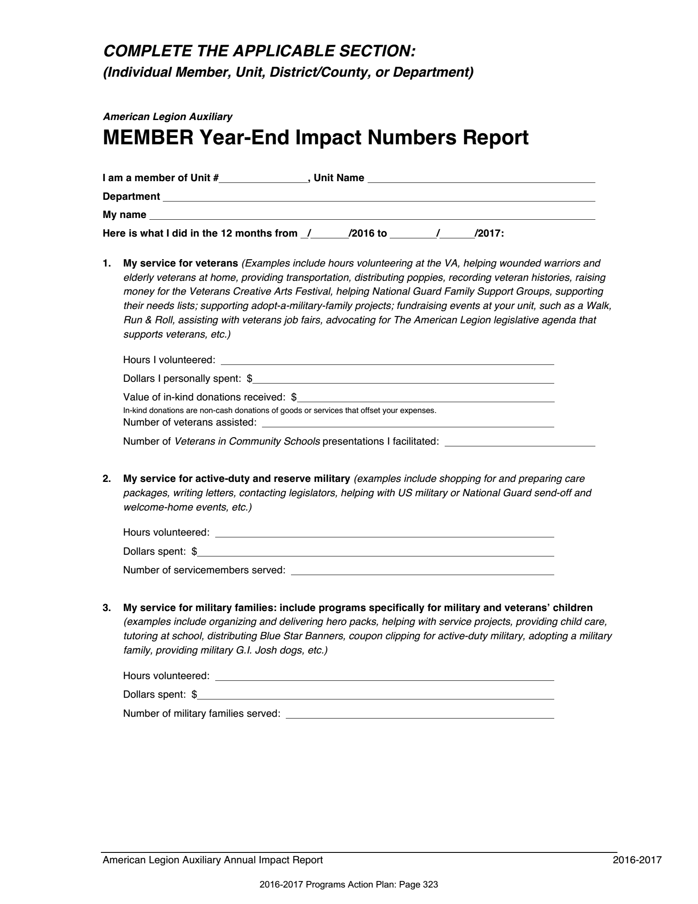
Turn In To Unit President by April 15th

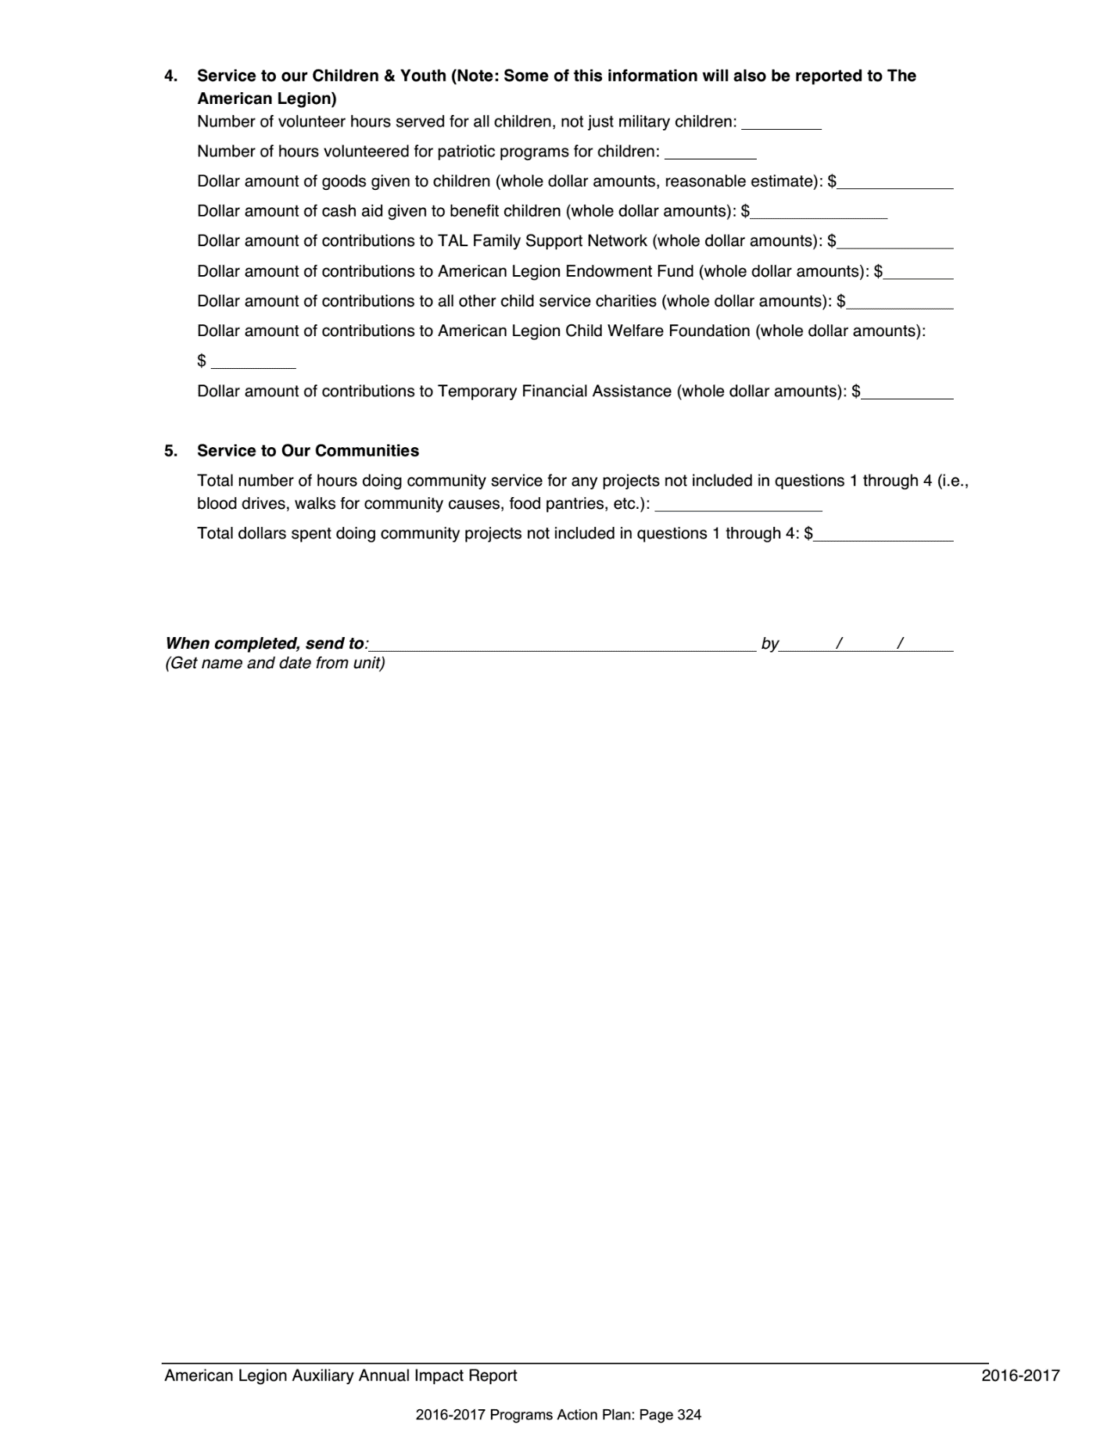

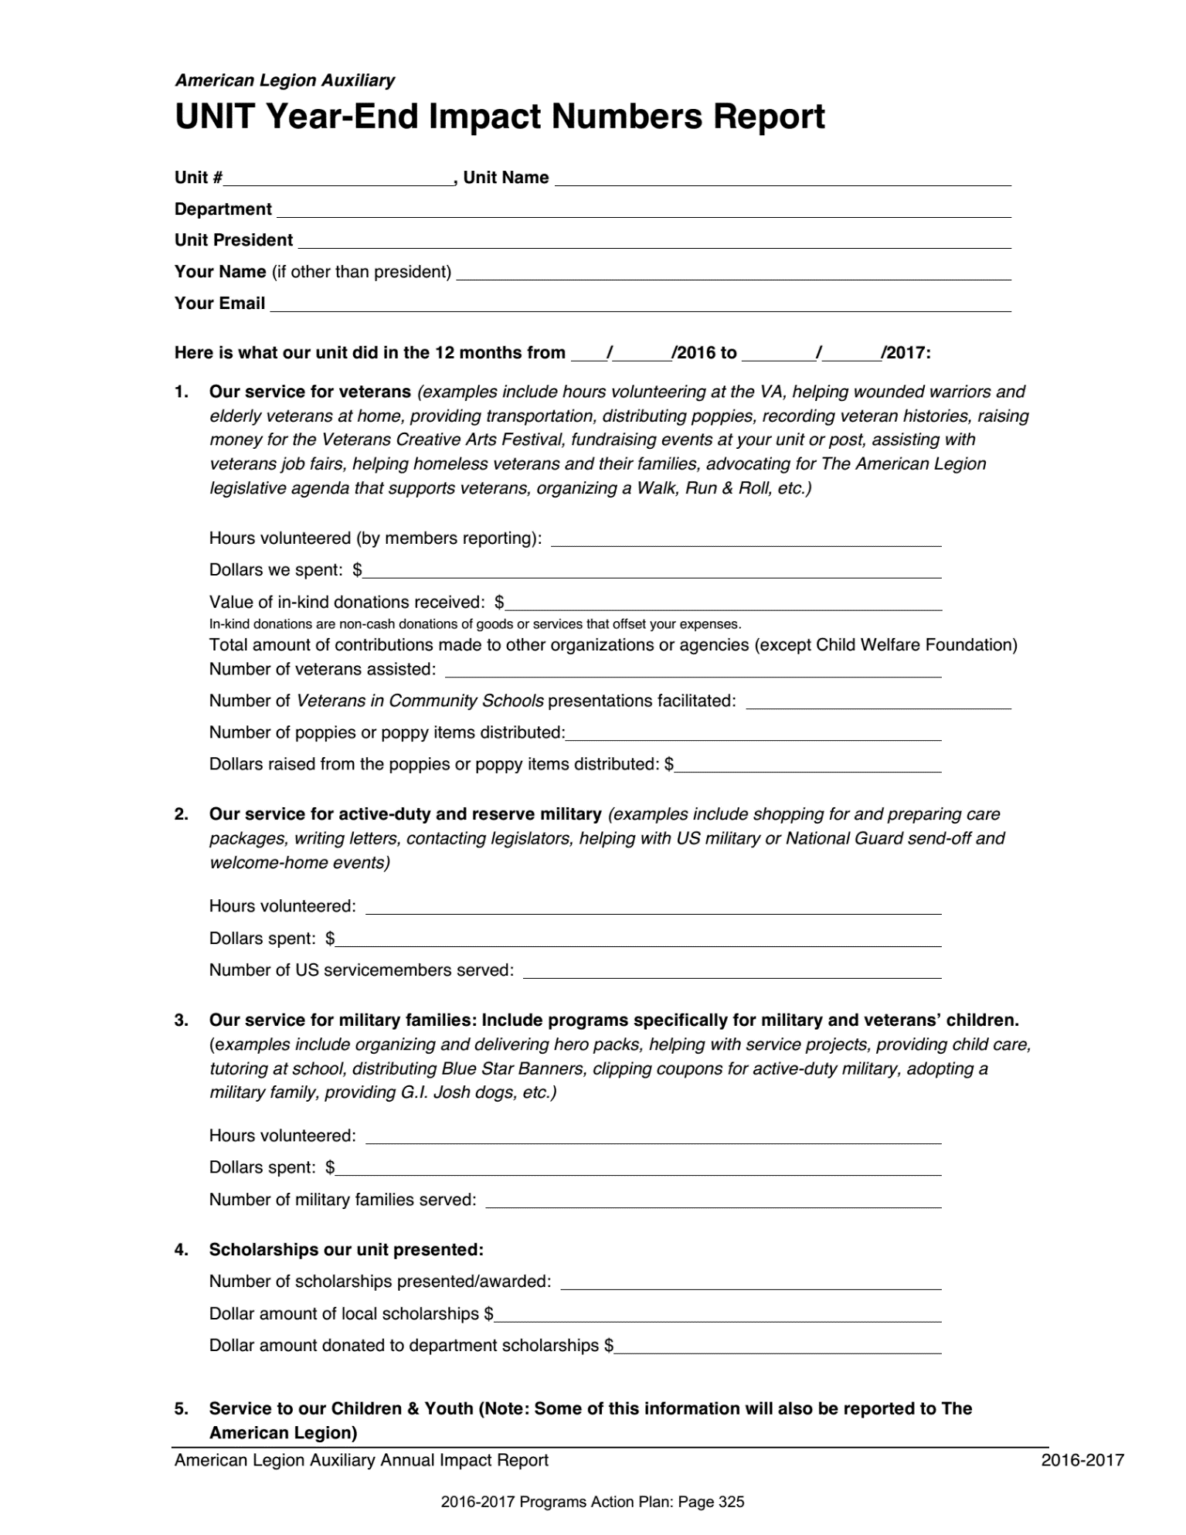
Turn In To District President by May 1st
Turn In To District President by May 1st

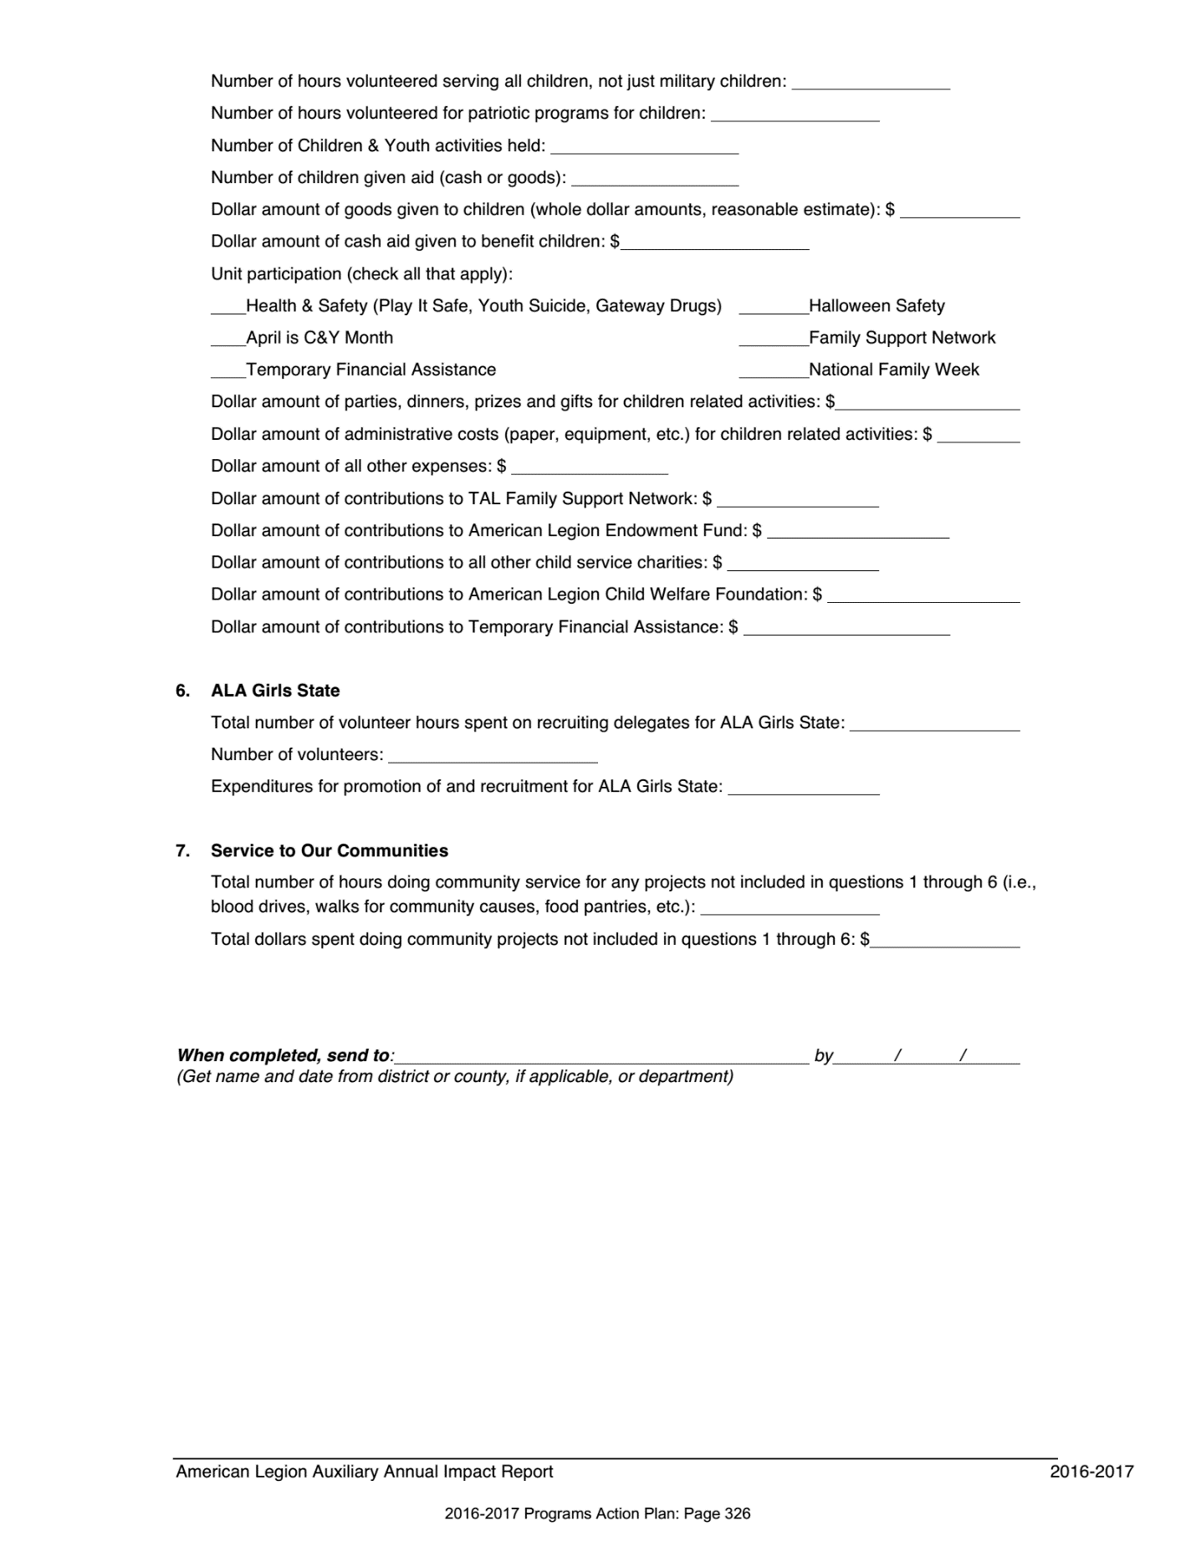

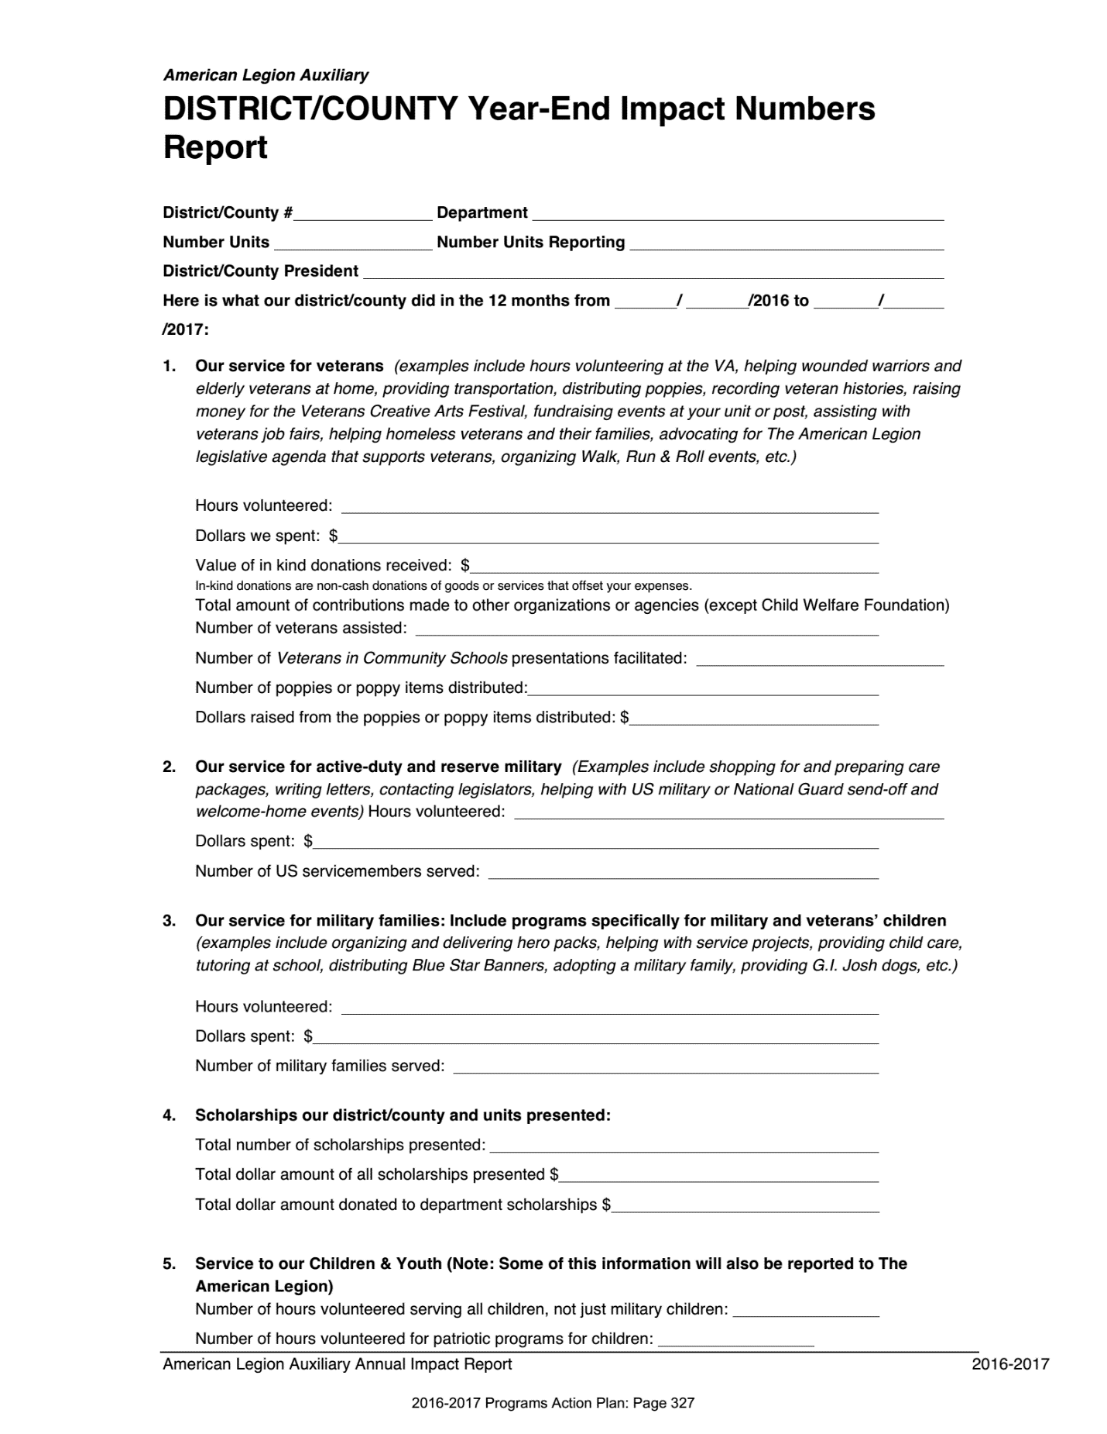
Turn In To Department Secretary by May 15th
Turn In To Dept. Secretary by May 15th

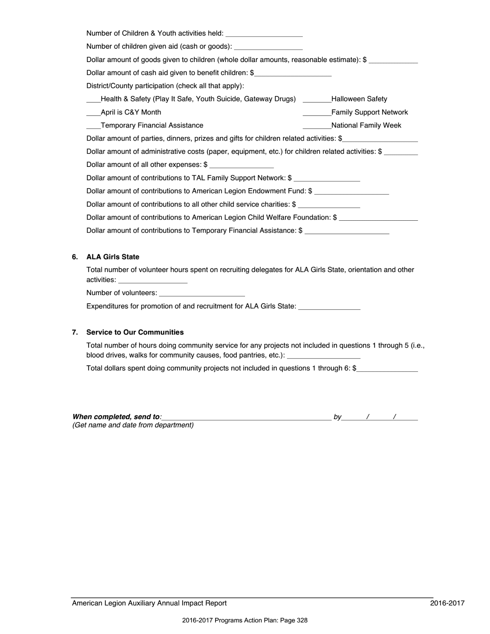

IMPACT HOUR TRACKING SHEET
