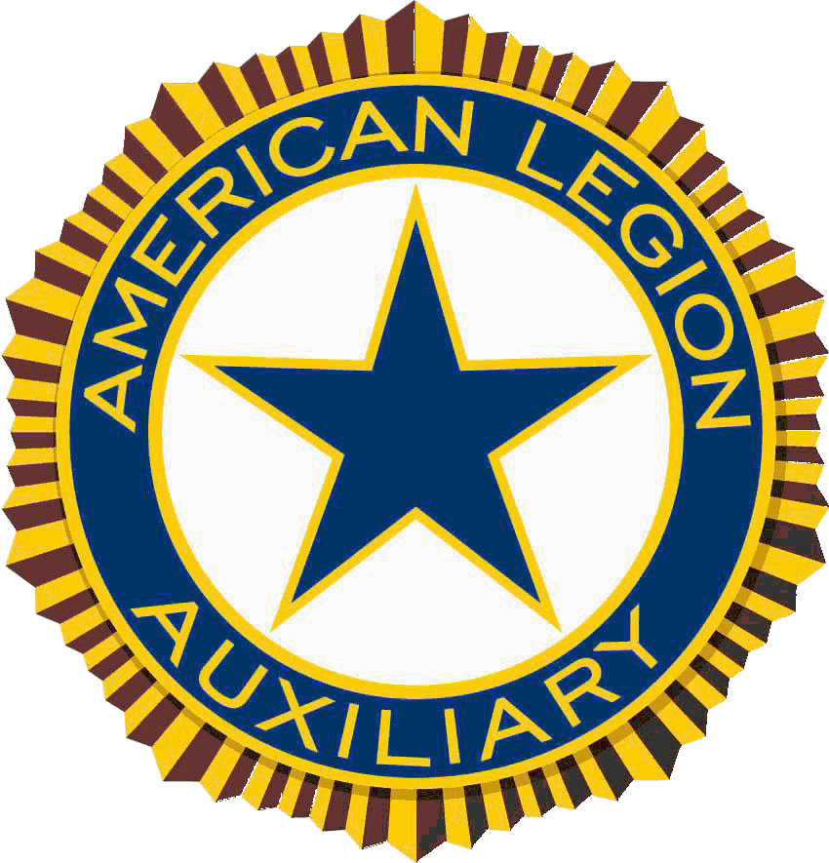
American Legion Auxiliary
UNIT NAME, UNIT NUMBER
Unit Address, Ohio ,Zip

Date:

Dear (name of prospect)
I am writing this letter to ask for your consideration in giving a kind-hearted donation to our Military Family Assistance Fund. As you know it is the mission of the American Legion Auxiliary to assist Veterans, their families and their communities. The Military Family Assistance Fund is a Department of Ohio American Legion Auxiliary Program developed in order to come to the direct aid of our veterans and their family’s right here in our communities in Ohio. This year we are appealing to others outside our organization that have that same aspiration, to contribute their financial support to assist Ohio’s heroes that find themselves in need.
The program offers financial assistance for eligible veterans and current military and their families. Donations such as yours would make funds available to assist in covering the costs of maintaining basic family needs such as the costs of shelter, food, utilities, and health expenses in order to keep a stable home environment. Funding can include, but is not limited to, family living expenses including rent, mortgage payment and utility bills; medical expenses; childcare for working parents; insurance premiums, and assist with necessary home repairs.
Since its inception in 2012, the Ohio Military Family Assistance Fund has assisted 43 families totally over $50,000.00 in financial assistance. It aims at providing the funds necessary to keep the lights on, a roof over their head, or a vehicle to drive until they obtain employment or their veteran’s benefits are available. We have seen the benefits of this fund and know that it is a worthy cause. The need is there, we only want to be able to continue to provide the funds to support it. Grants range from $500-$1500 per family.
We invite people to participate in our Military Family Assistance Fund Raising Campaign. We will be happy to see your active participation in our program.
For additional information I have enclosed a brochure outlining the program or you can visit our website, www.alaohio.org.
Please feel free to contact me for any help or information about this program. Your support is necessary for the success of our program.
Sincerely,

Name
Unit # President

The American Legion Auxiliary is a 501C-19(Veterans Service Organization). Contributions to our organization are tax deductible. Per IRS determination letter: “Contributions made to Units listed were deductible as provided by section 170 of the Code.
Acknowledgment of Receipt
You should send the following letter upon receipt of the actual gift. The letter serves as a receipt, you should include language in conjunction with IRS requirements.

American Legion Auxiliary
UNIT NAME, UNIT NUMBER
Unit Address, Ohio ,Zip

Date:

Dear (name of prospect):

Unit Number, Unit Name and the American Legion Auxiliary, Department of Ohio gratefully acknowledges your financial support. Your donation of $XXX for the Military Family Assistance Fund will help make it possible for the American Legion Auxiliary to provide outreach support to our veterans and current military that find themselves suffering from a recent emergency or financial hardship.

We remain committed to service to our veterans and military. Our program continues to advance because of you.

Please retain this acknowledgement for your 20XX tax records. Thank you for your support and many blessings to you and your family for your investment in the American Legion Auxiliary.

Gratefully,

Name
Unit # President

The American Legion Auxiliary gratefully acknowledges your financial support in the amount of $ XXX check number YYYY, Dated XX/XX/XX. Your donation may be tax deductible as allowed under federal tax laws. The American Legion Auxiliary Department of Ohio, 31-4115600, PO Box 2760, Zanesville, Ohio, 43702, (740-452-8245), is a not-for-profit veteran’s service organization duly registered with the Internal Revenue Service and is tax exempt under section 5019(c) (19) of the Internal Revenue Code; our federal group tax exemption identification number is GEN 0964. No goods or services were provided in return for this total contribution.

