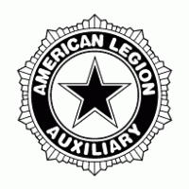
CHAIRMAN
Alice Teynor
524 Prospect Street
Bucyrus, Ohio 44820
(419) 563-5166 - CELL
Email – ateynor@gmail.com
REPORT DUE: April 15, 2019
AUXILIARY EMERGENCY FUND

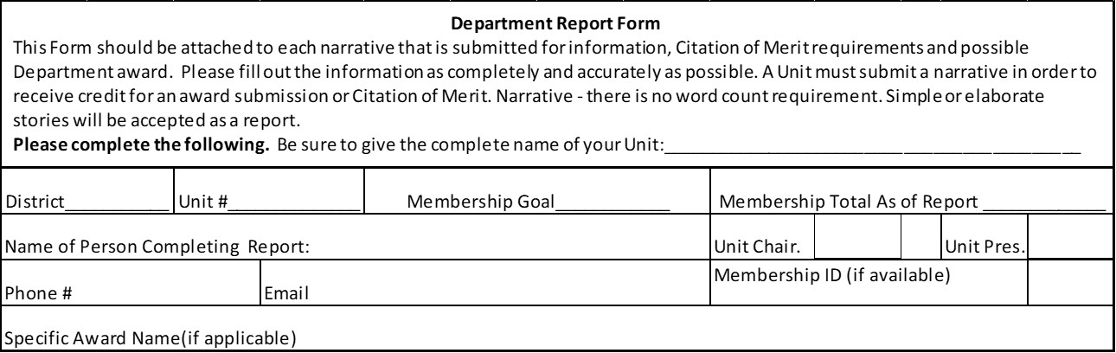

Narrative must be typed written in narrative form.
Narrative must not exceed 1,000 words. (Can be fewer words if program dictates)
Narrative may include photographs and news articles.
Optional-A copy of your Unit ALA Impact Form (Only necessary if it is required based the Plan of Action Directions)

The National Cover Sheet is included on the backside of this form. Please fill out the Unit or Member Portion and send with the Narrative this sheet, the back of this sheet and your Narrative to your District or Department Chairman

Report Deadline: April 15, 2019 Narrative Deadline: April 15, 2019

MAIL TO DEPARTMENT AEF CHAIRMAN

Alice Teynor
524 Prospect Street
Bucyrus, Ohio 44820
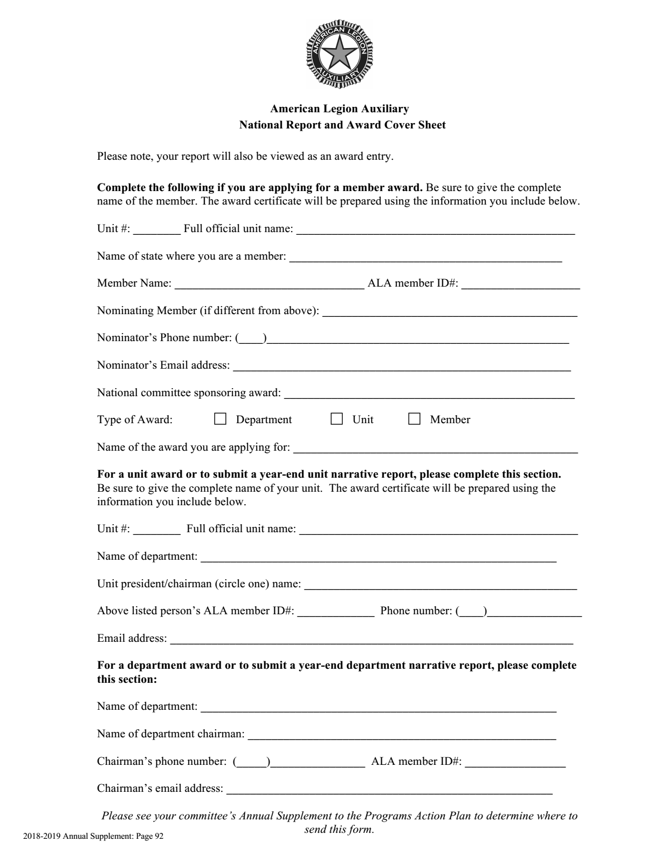
AUXILIARY EMERGENCY FUND

What is this program, and why do we have it?

The Auxiliary Emergency Fund provides temporary emergency financial assistance to eligible members during times of financial crises or weather-related emergencies and natural disasters and promotes awareness and knowledge of the program.

What Can You Do?

- Familiarize each unit and department with what AEF can and cannot do, where to locate the current application and how to apply.

Ideas:

Member
- Distribute the “Before you Begin – Frequently Asked Questions” sheet and AEF brochure found at www.ALAforVeterans.org to eligible members. Promote as a benefit to new members.

Unit
- Have printed applications and AEF brochures available during unit meetings and at the local post.

- Help the National Auxiliary Emergency Fund obtain donations by supporting department and unit fundraisers.

Ideas:

Member
- Support fundraisers sponsored by your department and unit.
- Make a personal donation to the AEF. Donations of $50 or more will receive a pin requested by your department from National Headquarters.

Unit
- Put an AEF donation can in your local post (visit www.ALAforVeterans.org for a free, downloadable can label). Solicit local businesses for monetary or in-kind donations to your unit for AEF.
- Schedule an annual “Members Helping Members” night at your local post. Not only is this a great time for an AEF fundraiser, but it gives you the opportunity to share information about what makes a member eligible to receive help from the AEF. Have membership applications available, and sign up new members during an event. Legion members might sign up eligible relatives in order to provide this protection for them. Prior to the event, be sure all unit members have read and are familiar with the AEF frequently asked questions as well as the criteria for assistance.
- Have a balloon raffle. Sell balloons with a ticket inside that matches a prize. The buyer will not know what they have won until they have popped the balloon. See donations for the prizes and display them on a table. Examples could be gift cards, merchandise, handmade crafts, homemade cakes/pies/cookies. Plan to have a grand prize that would appeal to anyone.
- Do a grab bag.
- Set a dollar amount and have members purchase items (things anyone could use that will fit into a brown paper lunch bag, can include gag items). Have Post members, Sons, guest, etc. purchase them.
- Have a grand prize bag.

Programs and Activities

- The AEF brochure is available through departments and also online at www.ALAforVeterans.org

- Please use the current form and follow directions to ensure that evaluation and processing are completed in a timely fashion. Incomplete applications can delay the application process. The current application and expedited application are available at www.ALAforVeterans.org.

- Forms are available to order pins for individuals who donate $50 or more. AEF Donation Pin Order Forms are available at www.ALAforVeterans.org, by contacting National Headquarters at (317) 569-4500, or by emailing your request to aef@ALAforVeterans.org. Departments track and distribute pins to individual members.

- AEF frequently asked questions and additional AEF information are available on the AEF page at www.ALAforVeterans.org.

- The following core rules apply to the Auxiliary Emergency Fund:
  - Temporary assistance to eligible members during:
    - A time of financial crisis when no other source of aid is readily available to pay for shelter, food and utilities.
    - Weather-related emergencies and natural disasters, for food and shelter.
    - Educational training for eligible members who lack the necessary skills for employment or to upgrade competitive workforce skills.
  - Assistance will not be granted to pay accumulated debts or medical expenses. The intent is to help members who have suffered a financial setback and is meant to be a bridge offering a helping hand until financial stability is re-established. Incomplete applications and missing documentation will significantly slow processing the case file.
  - Eligibility: Persons who have been members of the American Legion Auxiliary for at least the immediate past two consecutive years and whose current membership dues are paid at the time the emergency occurs (three consecutive years’ dues) may apply for assistance.
  - Assistance provided: The maximum grant amount is $2,400, disbursed as the Auxiliary Emergency Fund Grant Committee determines.

Auxiliary Emergency Fund Awards Deadlines:

- Department Award: Largest Contribution
- Deadline: June 1, 2019

- Unit Award: Unit Contributing the Largest Amount (per capita)
- Deadline: June 1, 2019

- Department Award: Department Contributing the Largest Amount (per capita)
- Deadline: June 1, 2019

Auxiliary Emergency Fund Reporting:

Mid-Year Reports
Mid-Year reports reflect the program work of units in the department, and are intended as an opportunity for mid-year correction. Each Unit AEF chairman is required to submit a narrative report by January 5, 2019 to the Department AEF chairman.

Year-End Reports
Annual reports reflect the program work of units in the department, and may result in a national award for participants if award requirements are met. Each Unit AEF chairman is required to submit a narrative report by April 15, 2019 to the District AEF chairman.

DEPARTMENT AWARD INFORMATION & DEADLINE

“Ardith Cooper” Plaque – This plaque will be awarded to the Unit with the highest donations per capita - to be given at Department Convention.

