

BULK MAILING FOR NOVEMBER 2017

To: Unit Presidents

District Chairmen

Department Chairmen

Depart. Executive Cmte

Hospital Representatives & Deputies

Past Department President

PLEASE PASS THIS INFORMATION ON TO THE OTHER MEMBERS OF YOUR UNIT. YOU CAN ALSO LET THEM KNOW THAT EACH BULK MAIL IS POSTED TO THE DEPARTMENT WEBSITE, WHERE THEY CAN REVIEW AND PRINT ON THEIR OWN SHOULD THEY WANT TOO!! HAVE A WONDERFUL THANKSGIVING HOLIDAY!

**Included in this mailing:**

* President’s Message – All members
* **MID-WINTER INFORMATION** (HOUSING INFO, WORKSHOP AND BANQUET FORM)
* Membership (yellow) – Membership Chairman and All Members
* Centennial Count Down & Public Relations – All members
* Centennial Questionnaire
* AEF (lavender)
* Buckeye Girls State – BGS Chairman
* Chaplain (ivory)
* Junior Activities Patch Program (white) – Jr. Activities Chairman
* Leadership (ivory) – All members
* National Security (blue)
* Poppy (cheery)
* Department Apparel Form for ALA Navy Vest

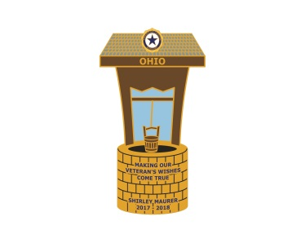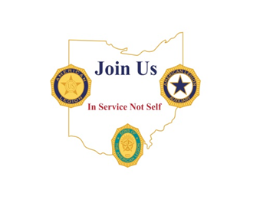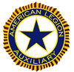

***Shirley Maurer***

***Department President***

***06247 State Route 219***

***New Knoxville, OH 45871***

***419-753-2486 or 419-733-3397***

[***pmaurer@nktelco.net***](mailto:pmaurer@nktelco.net)

November, 2017

BULK MAILING

Hi Ladies,

Can you believe it is almost Thanksgiving? Most of us don’t know how lucky we are to have a roof over our heads and food on the table. We had a tornado go through on November 5th, eighteen miles from our house and there are quite a few people out of work and don’t really know when they will be returning. One business was demolished and there are several other businesses that are severely damaged. Whether they are veterans or not, they will probably be struggling over the holidays coming up. I hope you will seek out these individuals and help them as much as you can.

During the Holiday Season, there maybe soldiers, past and present, along with their families that have “wishes”. Please consider having a fundraising event that will benefit my special project, “Making Our Veteran’s Wishes Come True”. You can pull the application form off of the website [www.alaohio.org](http://www.alaohio.org). Just make sure it says on there Military Family Assistance Fund: “Grant a Wish” application. I am anxious to start granting wishes for our veterans.

Mid-Winter is fast approaching and I look forward to seeing many of you at the Conference. Conference and Housing information is contained in this Bulk Mailing. Remember that the American Legion and the SONS will also be staying at this hotel so please make your reservations early.

Don’t forget to bring your beautiful Poppy Usage creations to Mid-Winter for judging. If you cannot attend and bring your creation, please contact a local Unit to see if they have members attending or contact your District President. All proceeds from this project will be towards the Veterans Creative Arts Fund. This program is funded to help Veterans with PTSD to express themselves through the Arts. These items will be returned to the person submitting them at the conclusion of the Mid-Winter Conference on Saturday.

The American Legion will be having a Banquet on Saturday evening at Mid-Winter to honor the National Commander Denise Rohan, who will be attending the Legion conference. They have invited the Auxiliary and SONS to the Banquet. Tickets will be $30 per person. If you wish to attend, please make sure you make the necessary reservations.

You’ve heard of Black Friday, Cyber Monday, BUT have you heard of #Giving Tuesday? We have a day for giving thanks and two for getting deals. #Giving Tuesday, November 28, is a global day dedicated to giving back. Donate to the ALA Foundation on #Giving Tuesday to help ensure our worldwide mission of service to veterans, military and their families endures. Your support leads to job training, shelter, physical and mental health services and so much more. Gifts to the ALA Foundation on #Giving Tuesday will be matched up to the first $15,000. (Matching gift donated by Innovairre Communications) What a great way to double your gift and double our assistance to those in need. To give go to [www.ALAFoundation.org/givingtuesday or call 317-569-4500](http://www.ALAFoundation.org/givingtuesday%20or%20call%20317-569-4500) to learn more.

Wishing all of you a very Happy Thanksgiving.

Love to all,

Shirley

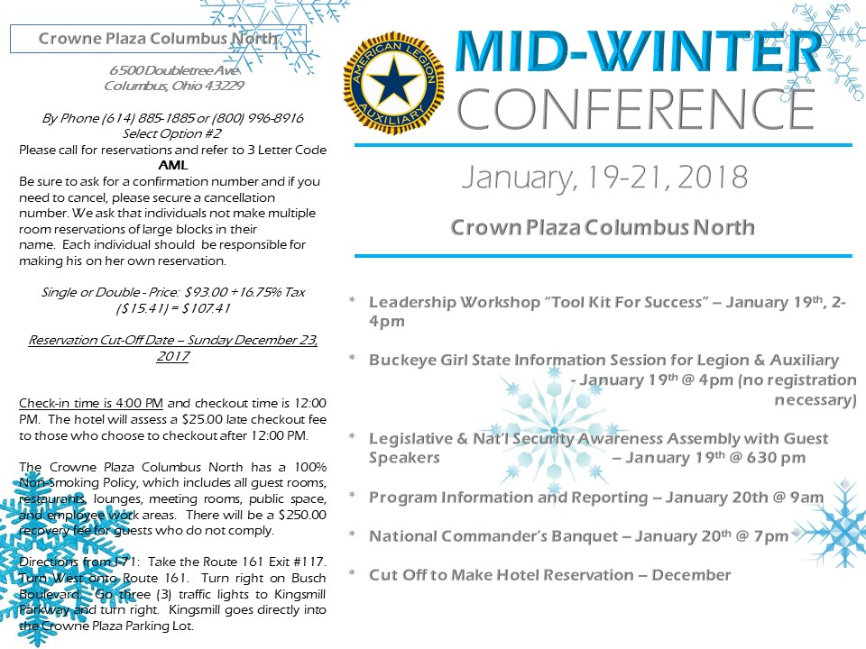

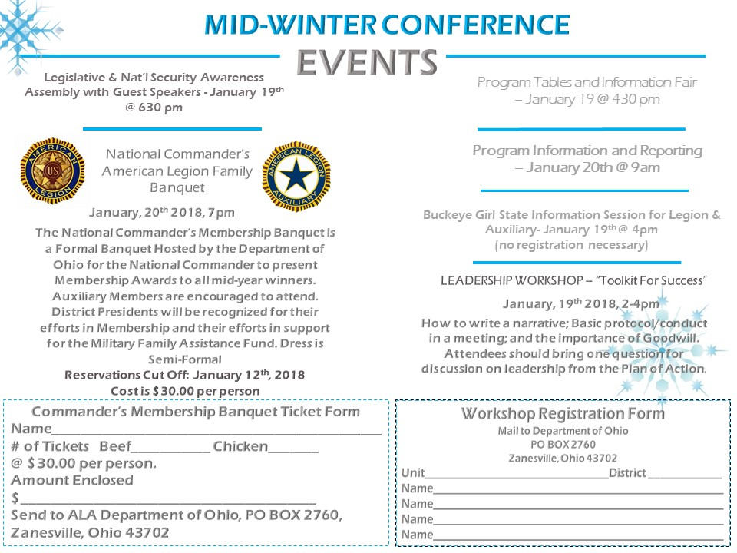

**Membership Is For EVERYONE!!!!!!**

**Join Us “In Service Not Self”**

Here we are into November already, WOW !! where has the time went? Before you know it with all the Holiday’s coming we will be into the New Year.

Are your Officers dues paid? Are you holding your membership? Why is there still “0” units? Have you read the Plan of Action? Are you Recruiting or Rejoining Members?

Just a few questions to ask yourselves as Membership Chairmen. We are still behind last year’s numbers for membership and I know we are all working hard to get caught up, perhaps a postcard to those who have not paid yet would help or perhaps a personal phone call would do the trick. We missed the deadline to help Department get $1,000 for no “0” units but we can still get that $500, “Pot of Gold” by March 17,2018. Let’s not forget those UNIT incentives that are available, could your unit use the extra cash? It is possible!!!

**CONGRATULATIONS TO ALL THE DISTRICTS WITH NO GOOSE EGGS!! ALSO TO THOSE UNITS THAT HAVE MADE GOAL!! YIPEEEEE!**

Just a note from Heather in case you didn’t see it.

*Do have to give credit where credit is due, even though we may not have made the $1000 Incentive EVERYONE was working so hard to help achieve! Don’t frown or think it was for nothing, because I have been doing this job for well we will just say for now a while and this is by far the least amount of “Goose Egg” Units I have seen at this time of year I think for a very, very very longgggg time!!! GREAT WORK……Keep it up you all are very much appreciated.*

**THANK YOU,** **ALA Department of Ohio** **Membership Clerk** **Heather Wilson**

**Department Award**: Find Your Pot ‘O’ Gold

**Award**: $500 Presented to: **Departments** **Deadline: March 17, 2018** Award will be presented to departments that have no units with ‘0’ membership as of March 17. To qualify, National Headquarters must receive membership by March 17.

[](https://www.google.com/url?sa=i&rct=j&q=&esrc=s&source=images&cd=&cad=rja&uact=8&ved=0ahUKEwjFhd3iqcPXAhWI7IMKHY_jCdIQjRwIBw&url=https://www.oshasafetymanagement.com/blog/implementing-safety-incentive-program/&psig=AOvVaw2rVw-qQNFOZdRv6pwP3W_G&ust=1510929600943075)**UNIT INCENTIVES**

**#1 -** $100 – To the **FIRST GOAL** Unit (if more than one will be drawn at **SOI** – Sept. 23, 2017 or **MID-WINTER** – Jan.19, 2018) ---- **Won by Unit 381 District 2 – SOI**

**#2 -** $50 – To **TWO** Units with all officers paid by **November 11, 2017** (Officers are President, 1st & 2nd Vice, Secretary, Treasurer, and Membership chairman for this purpose) If officers dues are not paid by Dec. 31, 2017 then they are not in good standing and should not be holding respective office. Will be drawn at **MID–WINTER** – Jan.19, 2018

**#3 -** $50 – To the Unit with highest increase of **Junior** members from **Aug 1, 2017** to **May 1, 2018**, (to be given at **Department Convention**)

**#4 -** For all **GOAL** Units by June 1, 2018, a drawing will be held at Department Convention for **THREE**, 1st for $100, 2nd & 3rd for $50.

Surprise Awards: ???

For Mid-Winter more info to come!

[](https://www.bing.com/images/search?view=detailV2&ccid=0SX3Q/vK&id=4432C26079B5492A312A79E8AC40D0F520F89081&thid=OIP.0SX3Q_vKqbH9P3BuMC3BGgDIEs&q=column+clip+art+free&simid=607988450969192891&selectedIndex=58)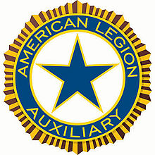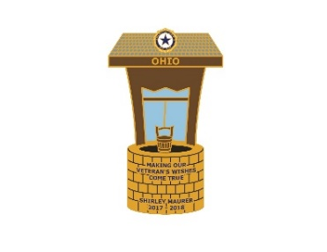

**CENTENNIAL COUNTDOWN**

Our History Continued - The years passed and membership grew – the result of the eligibility of World War II service-connected men and women. Girls State Programs were held in every Department, and the first Girls Nation was held on the campus of American University in Washington, DC, in August 1947.

Housing for war veterans and their families, rehabilitation of a new generation of disabled veterans, care of needy children, and concern for the prevention of another global conflict were the primary concerns of 1948.

The *National News*, the official publication of the Auxiliary, took on a more important role and was sent to every Senior member. At the winter meeting of the National Executive Committee, $50,000 was presented to The American Legion for the expansion of the Legion’s rehabilitation program.

[](https://www.bing.com/images/search?view=detailV2&ccid=JOB42ZNC&id=E7CB080166380AD4580540688433FB54C10F68B7&thid=OIP.JOB42ZNCyc-hxSXO70NcFgDbEs&q=centennial+clip+art&simid=607998428171339603&selectedIndex=0)

The 1950s arrived, and with the invasion of South Korea, the Auxiliary again raised its voice in support of the Legion’s demand for military training for all young men. In September 1950 President Harry S. Truman announced that the Armed Forces would be increased from 1.5 million to three million. That year a new high in membership was reached, with 975,000 members recorded.

[](https://classroomclipart.com/clipart/Clipart/School.htm)

The 26th Women’s Patriotic Conference on National Defense convened in Washington, DC, on January 24, 1950, and marked the last conference in which the American Legion Auxiliary would participate. The Auxiliary held the position that it could not take part in the adoption of policy resolutions since the Auxiliary followed the policies established by The American Legion. The rehabilitation program was broadened, with personal gifts from the Auxiliary given to 185,000 veterans in hospitals on Christmas Day, 1952.

I will stop here at the beginning of the 50’s of our Great History. Just a reminder, I found this history on alaforveterans.org. I will provide a little history each month.

**Unit History**

I was very honored to receive and attend, 3rd District’s General Daniel “Chappie” James Unit 776 for their 37th Anniversary Celebration on October 28, 2017. Their Unit was chartered in 1980 with 40 members. Their Unit was very fortunate as they had Past Department President Phyliss Nichoson and Past 3rd District President Barbara Gross as two great mentors their 1st year. They were a very small unit, but did big things throughout the years. Some of their history includes, feeding the homeless every 3rd Saturday, buying school supplies for the needy schools, donate to Past Pres Parlay Nurses Scholarships, send girls to BGS, provide Thanksgiving dinner for The Veterans, pass 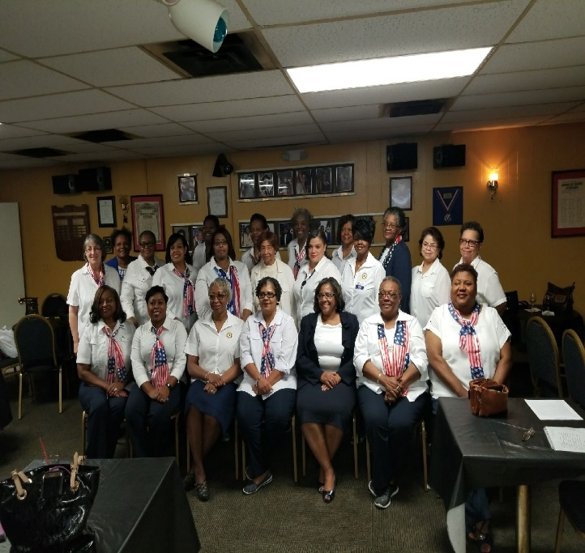out Gifts for Yanks on Christmas morning and each year they give out 60 Christmas baskets with 2 weeks of food and supplies. They have given over 1800 baskets in 30 years. On October 23 1999 this unit had a Make A Difference Day in which they donated 1200 pieces of luggage for foster children of Montgomery County. They were recognized in The Congressional Records of the 106th Congress July 26, 2000. Their first Unit President was Ola Matthews and their second President was Ora Lu Oliver. It was my pleasure to sit with these two ladies and hear of all the fun fund raisers they had to raise money for their many projects. As this unit continues to grow, their goal this year is 93 members, and with their strong commitment to The Veterans and their community this unit will continue to be a strong and a viable unit in The American Legion Auxiliary. Congratulations Unit 776.

**UPCOMING EVENTS**

**Please send me your upcoming events to** [**docadacca@aol.com**](mailto:docadacca@aol.com) **so that I can feature your activities.**

**Public Relation Reminders**

Now I need history of your units. What year were you chartered? How many members were chartered? Provide a brief history such as, who was your first Unit President, your other Unit officers. What were some of your first projects and programs that your Unit worked. How many members do you have now and your plans to grow in the next 100 years. Please email me articles to [docadacca@aol.com](mailto:docadacca@aol.com).

If your Unit had something in the paper, I need those articles. The article should have the name of the paper with the date it was published. So far, I only have one article. I know your Units have done much more.

**Important Date** In the Public Relations Plan of Action under Mid – Year report it has the date of January 5th, 2018 as the submission date. That is the date I must send it to The Central Division 2nd Vice Public Relations Chairman. I need your report by December 15th, 2017. Please remember this date.

***Debbie Monroe***

***Department of Ohio 2nd Vice President***

***Public Relations Chairman***

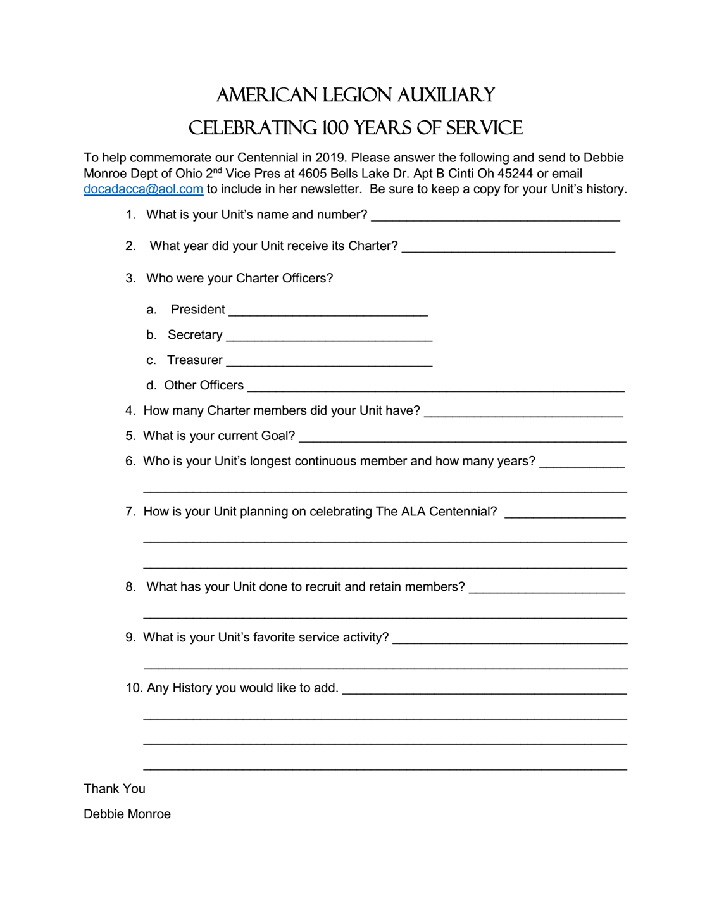

AUXILIARY EMERGENCY FUND

Our Auxiliary Emergency Fund is designed to serve members in a time of need. That need can be related to a natural disaster or a personal matter. Eligibility requirements for a member to request assistance are:

1. Must be a member of the American Legion Auxiliary for at least the immediate past two (2)years
2. Current membership dues are paid at the time the emergency occurs (three (3) consecutive years’ dues)
3. Maximum grant amount is $2,400 which is determined and disbursed by the Auxiliary Emergency Fund Grant Committee.

Two questions were received after our School of Instruction

Donations are ALWAYS needed. Use your creativity to plan a fun way to raise money. An easy and fun idea is to have a penny raffle: buy a book of 500 raffle tickets or create your own numbered from 1 to 500. Cut apart and fold so the numbers cannot be seen. Ask people to pick a ticket; they will owe (in pennies) whatever number they have picked. I.E. if the ticket has the number 420 on it, the buyer must pay $4.20. No buyer will have to pay more than $5.00. Total sales should equal $1,252. Include a ticket(s) that would be for a door prize as an incentive to play. Ask a local business to donate an item for the raffle. Or make one of your tickets worth an amount of money which would thus reduce your total sales profit.

Two questions were asked after our School of Instruction that I would like to share:

Question #1: who makes the final decision as to AEF grant approval, is it by group size, how many are awarded, is it Auxiliary only.

Answer: the final decision is made by Auxiliary Emergency Fund Grant Committee that consists of representatives from the headquarters of the American Legion and the American Legion Auxiliary. Assistance is awarded according to case findings and not by group size. The maximum amount that can be received is $2,400 based on the amount of available funds that have received.

Question #2: Can AEF funds come directly from a Unit?

Answer: This question is taken to mean can the Unit directly help a member in need. Yes, a Unit can certainly help one of their own and follow the same guidelines put forth. The amount given should not be included in the impact report but it can be included in the narrative.

I encourage all Units to donate to AEF. Women helping women, Auxiliary members helping other members. What a wonderful thing to do!

Carole Sowards, AEF Chairman

[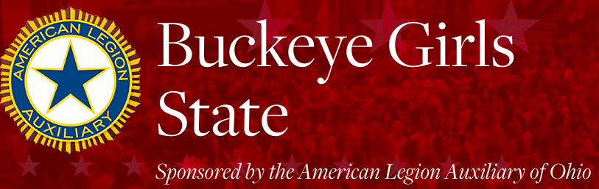](https://www.google.com/url?sa=i&rct=j&q=&esrc=s&source=images&cd=&cad=rja&uact=8&ved=0ahUKEwjIpNzY7sDXAhUJ74MKHeQrB7UQjRwIBw&url=http://hs.ils-k12.org/news/what_s_new/buckeye_girls_state_representatives_selected&psig=AOvVaw0MtJA9bModl7TRpSRozVi7&ust=1510845083734148)

**Scholarships and Awards**

It is important that during your interview process that you make sure your candidates are aware of the many scholarship/award opportunities available to ALA Buckeye Girls State Citizens.

Encourage your delegates to apply for the scholarships/awards. It is imperative that they

* Complete the application in its entirety
* Read and follow all instructions on the application
* Submit a clean and neat application
* Review spelling and grammar
* Write a well-written essay when required
* Take notice and meet the deadlines of the application
* Mail the application to the right place with right postage (when required)
* **$1,000 Buckeye Girls State Endowment Fund Scholarship**

Two outstanding delegates will be selected to receive a $1,000.00 scholarship.

Endowment Scholarship application will be distributed during the week of Buckeye Girls State. Applications will be reviewed by the staff and up to 10 girls will be chosen to be interviewed for this scholarship.

Eligibility –

* Completed the entire week of ALABGS
* Participated whole heartily in the program
* Scholastic standing
* **Girls Nation – Two Delegates and two Alternates (July 21-28, 2018)**

Every year, two outstanding girls from each ALA Girls State program are selected to attend ALA Girls Nation in Washington, D.C. As ALA Girls Nation “senators,” they campaign for political office, craft and debate the passage of legislation, and meet with their real-life counterparts on Capitol Hill.

Eligibility –

* Completed the entire week of ALABGS
* Participated whole heartily in the program (leadership, attitude)
* Desire and availability to attend
* Capable of writing a bill or resolution and support it (public speaking)

Application for this award is in each delegate’s packet. **The application must be returned by June 1, 2018.** Applications are reviewed by the staff and up to 10 girls will be chosen to be interviewed for this award.

* **US Senate Youth** **Program** – 15 candidates will be nominated for consideration (March 3-10, 2018) application for this award is in each delegate’s packet. **The application must be returned by June 1, 2018.**
* The United States Senate Youth Program, established in 1962 by the U.S. resolution, is a unique educational experience for outstanding high school students interested in pursuing careers in public service. The annual Program will be held in Washington, D.C., each March. Two student leaders from each state, the District of Columbia and the Department of Defense Education Activity spend a week in Washington experiencing their national government in action. Student delegates hear major policy addresses by Senators, cabinet members, officials from the Departments of State and Defense and directors of other federal agencies, as well as participate in a meeting with a Justice of the U.S. Supreme Court. All transportation, hotel and meal expenses are provided by The Hearst Foundations. In addition, each delegate is also awarded a $10,000 College Scholarship for undergraduate studies, with encouragement to pursue coursework in history and political science. Additional information can be found at education.ohio.gov/Topics/Other-Resources/Scholarships/US-Senate-Youth-Program.  
    
  **Program Eligibility**  
  The Hearst Foundation stresses the following desired qualities in candidates:
* Leadership and public speaking ability;
* High scholastic standing and demonstrated ability to achieve;
* Articulate and logical thought processes;
* Community and public service involvement;
* Participation in a wide selection of activities on and off campus, such as music and sports; and
* Adequate social skills to participate in a large and dynamic group with relative ease.
* **SAMSUNG American Legion Scholarship**

Scholarship applications are restricted to high school juniors who attend the current session of either The American Legion Boys State or American Legion Auxiliary Girls State program and are a direct descendant - i.e. child, grandchild, great grandchild, etc. - or a legally adopted child of a wartime U.S. military veteran who served on active duty during at least one of the periods of war officially designated as eligibility dates for American Legion membership.

Application process is done on line at [www.legion.org/samsung-scholarship-application](http://www.legion.org/samsung-scholarship-application). Scholarships are due no later than the first day of a participant’s American Legion Boys State or American Legion Auxiliary Girls State program. All applications must be submitted using the online application system by **11:59PM on this day**. Applications will not be modified after the due date or given a deadline extension under any circumstance.

Award Amounts

* Ten National Scholars receive $10,000 each (two from each region)
* Ten National Runners-Up receive $5,000 each (two from each region)
* Remaining Department Finalists receive $1,250 each guaranteed

Watch for other opportunities that may become available. The Board of Directors are always searching for additional resources to enhance educational opportunities for our delegates.

As always I’m available for recommendations/suggestions, concerns and questions.

Carol T. Robinson, Director

American Legion Auxiliary Buckeye Girls State

8483 Woodgrove Dr.

Centerville, OH 45458

937-436-1983 (h)

937-602-9365 (c)

abernia@aol.com

**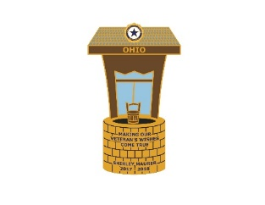**

**CHAPLAIN**

I hope you each take the time to write a special prayer or poem that can be included in President Shirley’s Prayer book. Your help is greatly appreciated! The member and unit to send me the most prayers or poems for Shirley’s book by January 15th will receive a special award.

Please read the Chaplains Plan of Action for details on all the awards.

We are to work with the American Legion supporting their programs and working our programs. While doing my do diligence I thought it important to pass along some of the important information about being a Chaplain. The following is information from the American Legion Website concerning Chaplains:

Being a chaplain has many purposes. One of its major purposes is to help persons grow in their relationship with God and one another. Also, we serve as a reminder of the transcendent and seek to develop an environment within which Legionnaires and our legion family are encouraged in their personal and collective moral and spiritual growth. We are to remind all Americans that God is the source of all rights and privileges. The American Legion Family is comprehensive in nature embracing all religions, faiths, and denominations within its ranks. The chaplaincy being non-denominational and nonsectarian wishes to minister to the spiritual needs of all without regard to either affiliation or no affiliation. Chaplains seek to minister to people wherever there is a need. For many, chaplains are the only ministers they will ever know, as they have no affiliation with either church, synagogue, or other religious institution. The role of the chaplain is ever increasing due to the aging of our membership. Each American Legion Family Chaplain should be alert to the physical and spiritual needs of his/her members.

Any member who is willing can serve as chaplain. However, any person serving in the office should have demonstrated a sense of spiritual maturity. He/she should be a caring person. There should be a desire to help others. The chaplain should have a positive attitude toward himself/herself, spiritual matters, the unit served, and The American Legion Family organization. Knowing that attitudes show, all chaplains should be proud of their positions and determine to do a good job. The chaplain ought to be willing to serve where there is a need. We can't be selective in our service for we have a responsibility to all. Neither can we serve only when it is convenient because chaplains should provide support as needed !

[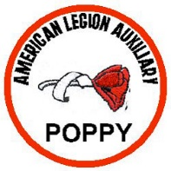](https://www.google.com/url?sa=i&rct=j&q=&esrc=s&source=images&cd=&cad=rja&uact=8&ved=0ahUKEwjE-a_fu77XAhVC5oMKHcRhDhoQjRwIBw&url=http://feedfrees.weebly.com/blog/american-legion-auxiliary-junior-patch-program&psig=AOvVaw3wmvB49XaKIQyLXGQ6ynHj&ust=1510762624188029)**JUNIOR ACTIVITIES PATCH PROGRAM**

The juniors have 3 levels of patches to work toward. Each level allows the juniors 4 years to complete and each level has a Program for Americanism, Community Service, Education, Leadership, Membership, National Security, Physical Fitness, Poppy, Technology, and Veterans Affairs & Rehabilitation.

**The Red Level** is for juniors that are in Kindergarten through 3rd Grade. Each program, at this level, has ONE activity that is Required to complete and TWO activities that are the choice of the junior to complete. A total of Three activities must be completed in each program to earn the patch. Each program, at this level, has a minimum of 6 objectives, allowing the junior a wide choice of items to complete. And remember, they will have 4 years to complete and earn the patch for each program.

**The Gold Level** is for juniors that are in 4th Grade through 8th Grade. This level has the same Programs, but each program has TWO Required activities and FOUR activities of choice. A total of SIX activities must be completed, but again the junior will have 4 years to complete the activities and earn the patch in each program. Every program, at this level, has at least 9 objectives to select from and complete.

**The Blue Level** is for juniors that are in High School or Grades 9-12. Again the same programs are here, but THREE activities are Required and SIX activities are elective. A total of NINE activities must be completed to earn the patch for any program. They will still have Four years to complete the programs at this level.

National has opened the Patch Program up to include our Junior S.A.L. members. Unit chairmen should meet with their Squadron Commanders and get a list of their junior members so that they could receive the information and begin working on the patches.

When a junior completes a program and fills out the activity sheet, please make sure that the completed, signed sheet ***(these sheets can be signed by any adult, not necessarily an Auxiliary member)*** is mailed to:

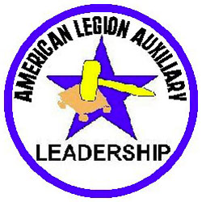[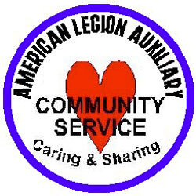](https://www.google.com/url?sa=i&rct=j&q=&esrc=s&source=images&cd=&cad=rja&uact=8&ved=0ahUKEwjQy6TSu77XAhUH7IMKHffMD1MQjRwIBw&url=http://feedfrees.weebly.com/blog/american-legion-auxiliary-junior-patch-program&psig=AOvVaw3wmvB49XaKIQyLXGQ6ynHj&ust=1510762624188029)

Aimee Shipley

Junior Activities Vice Chairman

632 S Elizabeth Street

Lima, OH 45804-1216

[aimeeshipley1983@gmail.com](mailto:aimeeshipley1983@gmail.com)

419-221-2837

[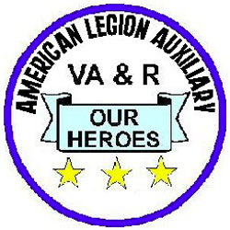](https://www.google.com/url?sa=i&rct=j&q=&esrc=s&source=images&cd=&cad=rja&uact=8&ved=0ahUKEwi4xd7uu77XAhVn2IMKHWYRCooQjRwIBw&url=http://feedfrees.weebly.com/blog/american-legion-auxiliary-junior-patch-program&psig=AOvVaw3wmvB49XaKIQyLXGQ6ynHj&ust=1510762624188029)

****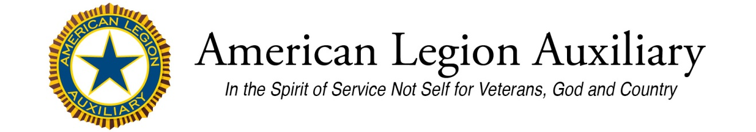

**GOODWILL STRATEGY TEAM 2 B – MAKE THIS PART OF YOUR UNIT INFORMATION**

(Add to the ALA National Standing Rules, immediately following the Code of Ethics, the following Code of Conduct which was adopted by the National Executive Committee)

**American Legion Auxiliary Code of Conduct**

The American Legion Auxiliary (ALA) Code of Conduct describes the principles of good behavior expected of all ALA members. A member’s participation in the American Legion Auxiliary is a privilege, not a right. The ALA expects every member to understand and abide by the Code of Conduct, and to exemplify the spirit of the principles of this Code. Every ALA member is expected to conduct herself in accordance with this Code of Conduct in order to foster and sustain a spirit of goodwill in the organization.   
  
Pledge to Abide by the ALA Code of Conduct  
  
A written pledge will include a signed and dated statement by a member that she has read and understands the American Legion Auxiliary's Code of Conduct, agrees to abide by the principles of good behavior described therein, and understands that violation of any part of the Code of Conduct may result in disciplinary action as allowed by the ALA.   
  
A member’s pledge to abide by the Code of Conduct will include her statement that a) she understands she represents the American Legion Auxiliary (ALA) and that her behavior reflects upon The American Legion Family at all levels, b) understands and agrees to adhere to the highest ethical standards to earn and protect the public’s trust in carrying out the Auxiliary’s mission, and c) agrees to be a good steward of ALA resources.   
  
**To fulfil the obligations of membership in the American Legion Auxiliary, a member serving in any capacity representing the ALA is expected to pledge to uphold the following standards of conduct:**

* To conduct herself with dignity, displaying good manners and good morals at all times.
* To respect the dignity of all persons and not bully, nor physically, mentally, or

psychologically abuse any other person.

* To demonstrate a high regard for the ALA mission, rendering quality service to veterans,

our military, their families, the community, and The Legion Family at all levels.

* To value all members regardless of their ability to participate in ALA meetings, events, or

projects.

* To be kind, considerate, and welcoming to members of all ages, ethnicities, and abilities,

regardless of their appearance or years of membership.

* To be a good citizen and a good neighbor by obeying local, state and federal laws and

regulations.

* To abide by all governing documents of the American Legion Auxiliary.
* To respect the property of the ALA and The Legion Family, her personal property and the

property of others; and to not abuse nor tolerate the abuse of property.

* To not abuse or tolerate the abuse of alcohol; to not use illegal drugs or tolerate the illegal

use of drugs.

* To honor and fulfil her commitments and financial obligations to the American Legion

Auxiliary in a timely manner.

* To be honest, helpful, and to not undermine others.
* To challenge all members to abide by this Code and appropriately address those who

violate the ALA Code of Conduct.

**SIMPLE WAYS TO RE-IGNITE YOUR INSPIRATION**

****

* It’s important to find moments that commit you to the reason why you joined.
* “It’s not about the destination, but about the journey. Your journey is to know who we are and what we do and TELL others.
* Inspiration comes in many forms and may be hiding around the corner:
  + Ask yourself “WHY” … make a list of why you joined
  + Keep a journal of what you do for: our veterans, their families and your community
  + Sometimes we get a surprise “bend in the road” that will throw you off balance. This is where you need to remember that you are human, and life happens.

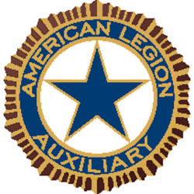

NATIONAL SECURITY

November is Military Family Appreciation Month. So what are you doing to help those families that have someone serving? Did you know that some of those families may not have anything and may not be able to have a nice Thanksgiving, so why not serve them for the day.Ementoring is a way to connect the military and the families as well.

Thank you to Unit 598 in Kettering OH for sending me pictures of the ceremony that they did for the POW/MIA day.

Please remember to send me a mid- year report by December 15, 2017. So I can send my report to National. You can email or snail mail it to me. I would love to have hear what everyone is doing for our military as well as if you are a working with the USO or the Red Cross. I know that some have been donating blood, so please send me a mid year report.

Holidays are here, so remember safety is always important, whether you are shopping in the malls, or online. Please make sure that to say to much. I do have to say this also, because it has happen to myself, watch those credit bill statements. Make sure that what is being charged is yours and only yours. That no one else has gotten your credit card number and has used it. Important to remember they do not care who they target. Security is important for all of us.

Have a nice Thanksgiving.

"The strongest people are not those who show strenght in front of us but those who win battles we know nothing about"

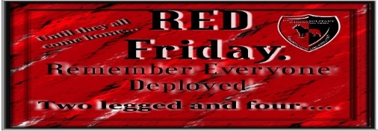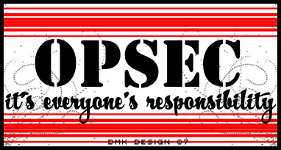

American Legion Auxiliary department of ohio

Lori Shields, 54 W. Barlow Rd, Hudson, Oh 44236

Phone: 330-352-7550 Email: lorishields@outlook.com

e-Mentoring

Have you heard about ementoring with the miltiary?

Here is an opportunity for you to help in another way that some may not know about. Since November is Military Family Appreciation Month, here is a good way to help.

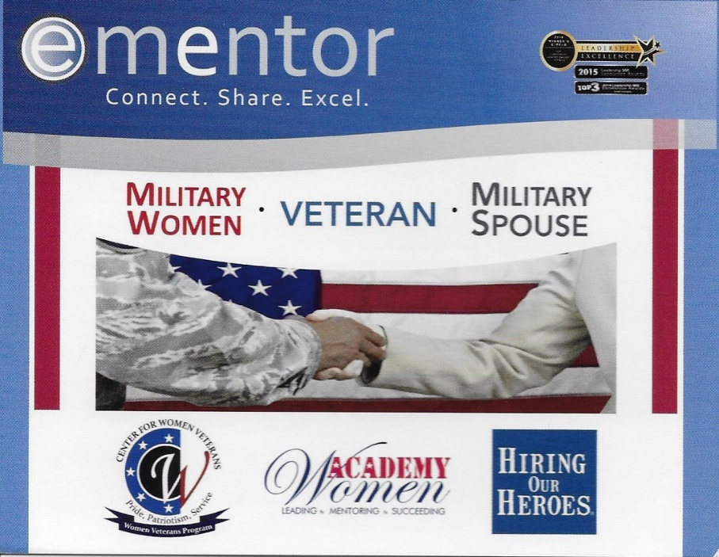

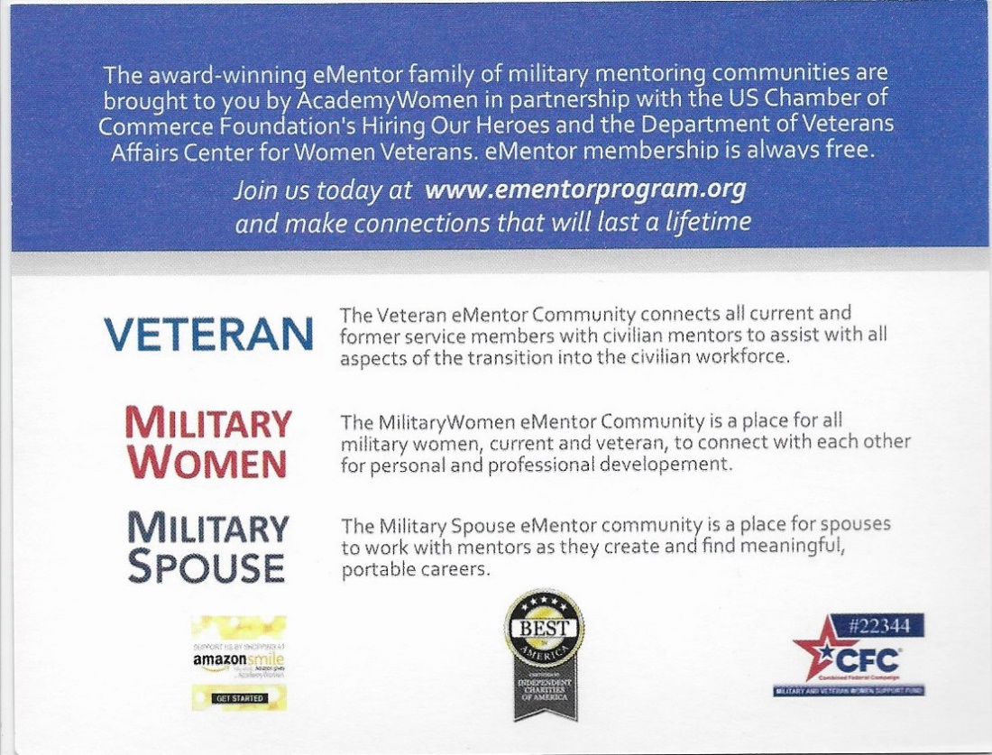

**Red Poppy2017 - 2018**

**For a Successful Poppy Program**

**Round 2**

Using the Poppy image, we can all participate in educating our communities on how the sacrifices of our military service members has been made. It is an ever lasting world of freedom and a great democracy that we live in.

Our job will be to comply with seeing that our successful Poppy program is carried out by completing the following in our contribution to this program:

- By now those Poppy orders have been sent or will be sent by deadline date of December 31, 2017. Reminder: this means in the hands of Department Headquarters by December 31st - *not mailed that date.* Also, this is a requirement for a citation of merit!

- Hopefully you have all started to draft your mini Poppy narrative from May 1, 2017 thru November 30, 2017 on just what you have done so far to promote the Poppy program. This synopsis is due to me by December 15th - *thank you!*

- Here's hoping you have all started your plans on making Poppy Usage Items with bringing them to Department Mid-Winter on January 19, 2018. This is a great way to express yourselves with making such items as corsages, trees, wreaths, centerpieces, bouquets, etc. by using those left over Poppies from your Poppy distribution day(s) last May. Reminder: the top five entries getting the most votes will each receive a gift and each entry will get a certificate of participation. A copy of this certificate can be included with your year-end narrative report. Also, any *Poppy related* media newspaper clippings may be included in your year-end narrative report.

SO02985_Have a happy turkey day with each of us counting our blessings for yet another year to serve!

*Gail Roddy*

Department Poppy Chairman

160 Ravenna Street

Hudson, OH 44236-3465

H-330-653-8928

e-mail: gailroddybgail@aol.com

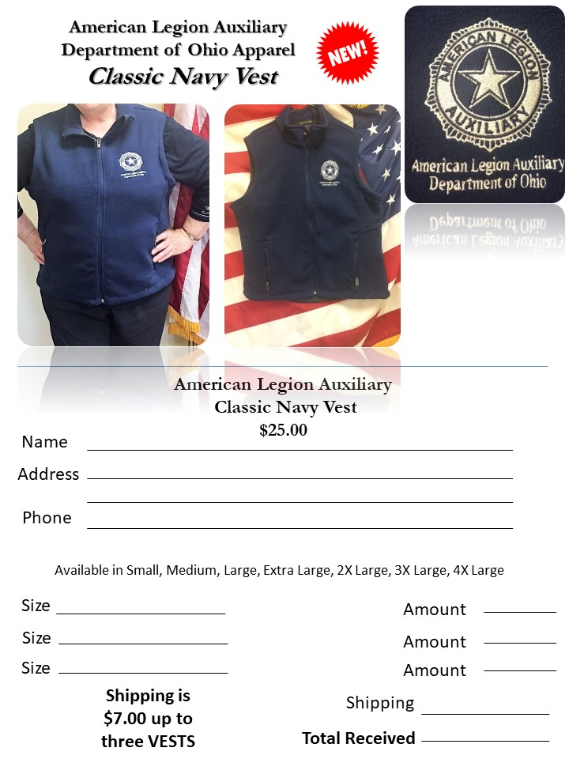

The END