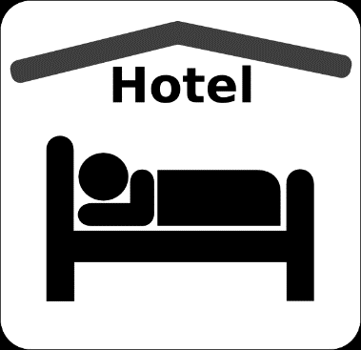

Poppy Shop
&
Department Jr. Convention

Hotel Accommodations
A Block of Rooms have been reserved at a Discounted Rate for Friday, April 6th & Saturday, April 7th, 2018
Individuals must make their own reservations by contacting:

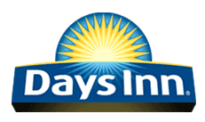
11410 US Rt. 250
Milan, Ohio 44846
Phone 419-499-4961
Group Name: American Legion Auxiliary
Price: $49.99 plus tax

Cut off for Reservation
March 5, 2018

