KIT OF REPORTS

THE FOLLOWING ATTACHED DOCUMENTS ARE YOUR REPORT FORMS FOR THE 2017-2018 ANNUAL YEAR

Tear Off Each Report Form, Fill Out, and Send to your Department Chairman or District Chairman along with your Program Narrative
The Packet Contains the Following
- Citation of Merit Requirement
- Information on Impact Report
- Information on “How To” Fill Out Report Forms
- Member, Unit, & District Impact Report Forms
- National Award Information and Cover Sheet
- Program Report Forms

- All of the report forms are included in this packet. You will also see this STAMP on the report forms that are required for the Citation of Merit.

- You can find all of the Plans of Action and the Report Forms on the Department Website: www.alaohio.com
- Don’t forget to complete your Unit Impact Numbers Report! It is now a requirement for the Citation of Merit.

UNIT REPORTING RECOMMENDATIONS

- The report form shall be attached to all narratives. This form states the award applying for, contact information, program name and boxes to be filled in at the bottom.
- Those boxes are total number of volunteers, total number of Junior volunteers, total number of volunteer hours, total $ spent, total number of veterans served, and total number of people affected.
- All zeros is the same as no report. There must be at least one (1) number in the boxes.
- A Unit may make a donation with no volunteer hours. There would only be a dollar amount in the total dollars spent.
- If Juniors do not volunteer in the program or the Unit does not have any Juniors, a zero would be put in the total number of Junior volunteers.
- The VA&R report should include the assessment from dues of $0.75 x each paid member and included in the total dollars spent. Also include this information in the narrative.
- The Children & Youth report should include the assessment from dues of $0.25 x each paid member and included in the total dollars spent. Also include this information in the narrative.
- Rules for narratives as listed in each Plan of Action.

YEAR END REPORTING

- All reports and applications shall be submitted by due dates as listed by Department Chairmen .
- An Annual Impact report shall be completed by the Unit and submitted to the District President. District President shall submit a District Annual Impact Report to Department Headquarters.
- Reports must be submitted as specified below in order for the Unit to receive the coveted “CITATION OF MERIT”
- All required reports must be made on OFFICIAL REPORT FORMS. A report form with nothing reported does not count as a report received.
- District Chairman shall track all Unit Reports received on a District worksheet and submit to Department Chairman by the date specified in the Plan of A

CITATION OF MERIT REQUIREMENTS
Resolution Adopted Department Convention, 2014.

PROGRAM REPORTS REQ’D MAIL TO DEADLINE
Americanism 1 District Chairman April 15
Bonding Fee * 0 Department Headquarters May 1
Chaplain 1 Department Chaplain April 15
Children & Youth*** 1 District Chairman Deadline Date
Community Service 1 District Chairman April 15
History 1 Department Chairman April 15
Legislative 1 Department Chairman April 15
Membership ** 0 Dept. Headquarters GOAL by last day of business in May
National Security 1 Department Chairman April 15
Poppy *** 1 Department Chairman Deadline Date
Plus Small Poppy Purchase **** Department Headquarters Dec 31
Veterans Affairs & Rehab 1 District Chairman April 15
Unit Year-End Impact #s Report 1 District President May1

* The Unit Bonding Fee must be paid and received in Department Headquarters on or before May 1 of the year for which it is due.

** Membership Goal is set by Department and listed in the Buckeye Messenger. Transmittal forms accompanied with properly marked unit rosters must be received in Department Headquarters on or before 10:00 AM the last day of business in May of each year; all transmittals must be accompanied by a check in the correct amount. Do not include any other moneys in your check for Membership dues.

*** Deadline date for Report is determined by the Department Chairman and is stated on the annual report form.

**** Purchase of small veteran-made Poppies for distribution in your community must be made through Department Headquarters. Small poppies must be ordered and paid for by December 31 of each year to be considered for a Citation of Merit. Send Poppy Order Form with check in correct amount payable to:

AMERICAN LEGION AUXILIARY
DEPARTMENT OF OHIO, INC.

P O BOX 2760

ZANESVILLE OH 43702-2760

All required reports must be made on OFFICIAL REPORT FORMS. A report form with nothing reported does not count as a report received.

Reports can be Emailed, Faxed, or US Postal Service. The most important thing is that Units report their good works!
Please Send in your Reports

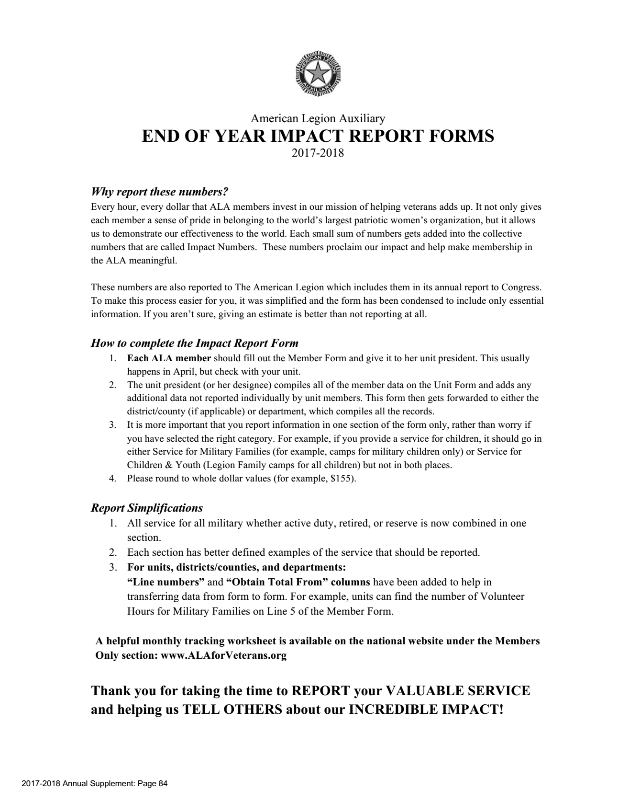

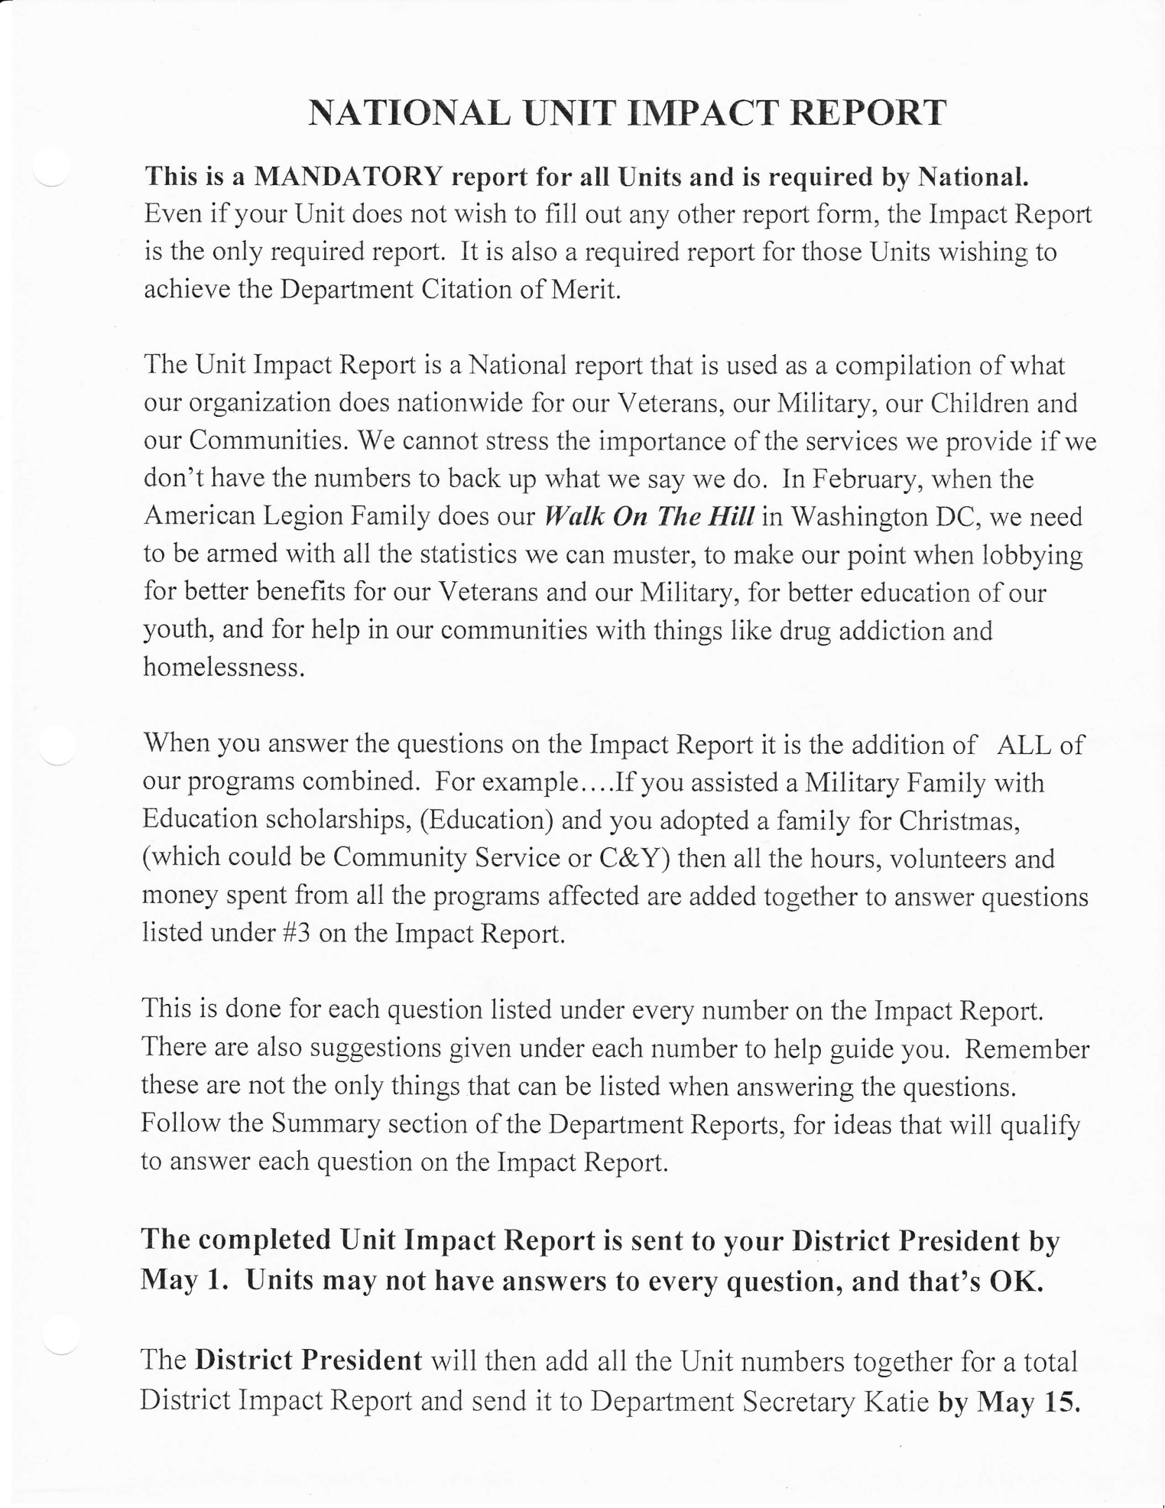

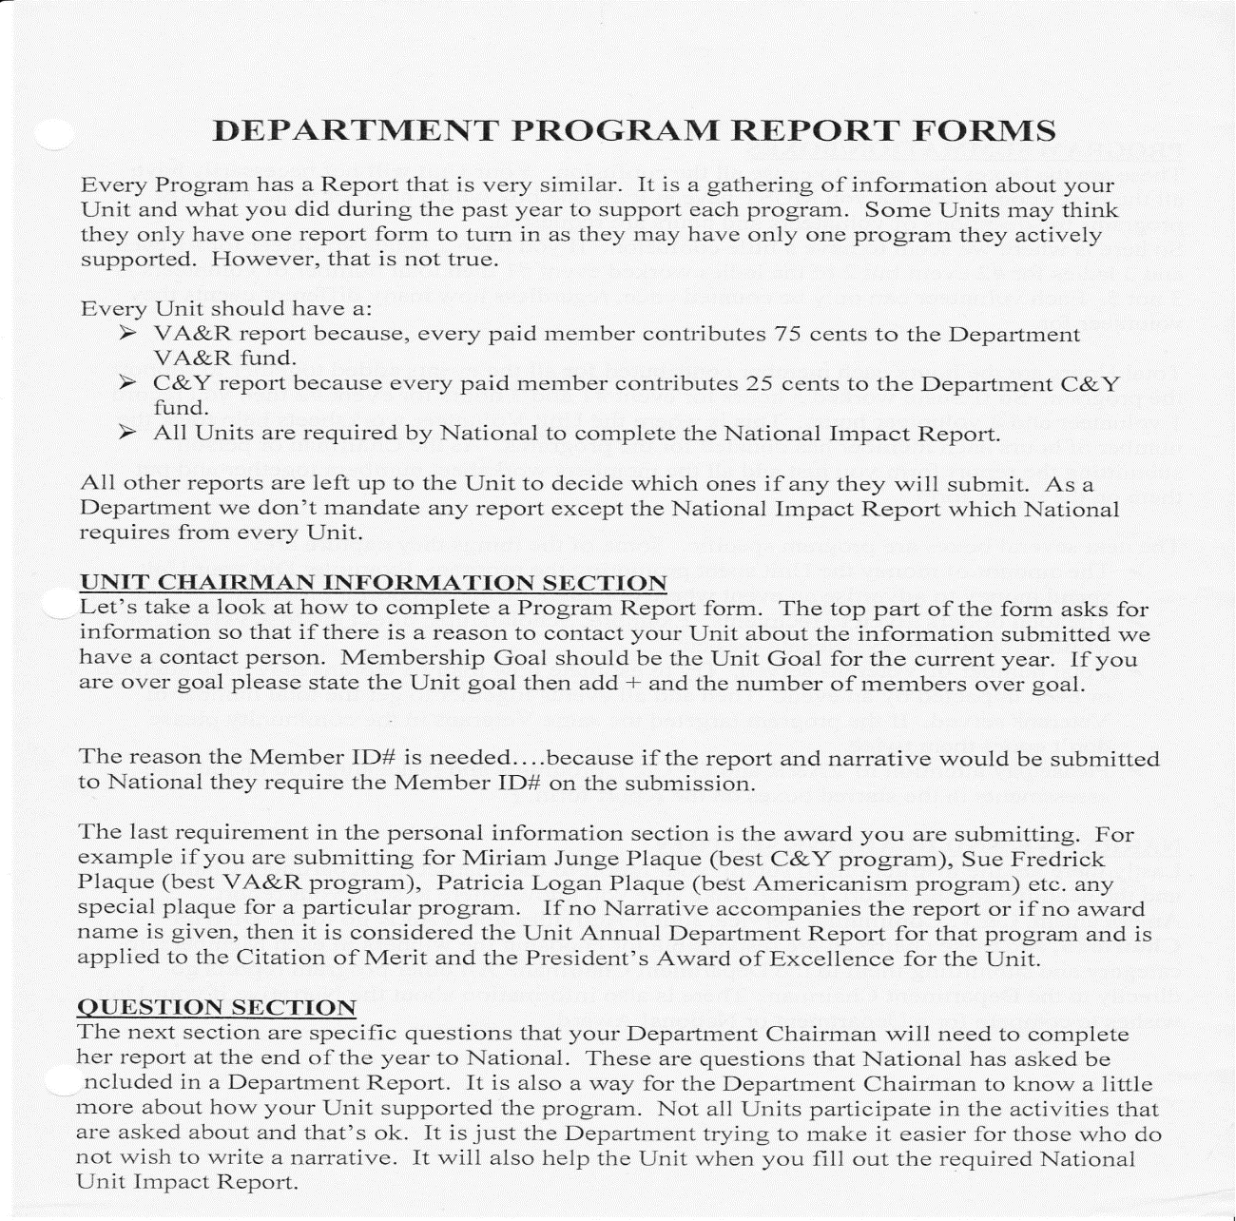

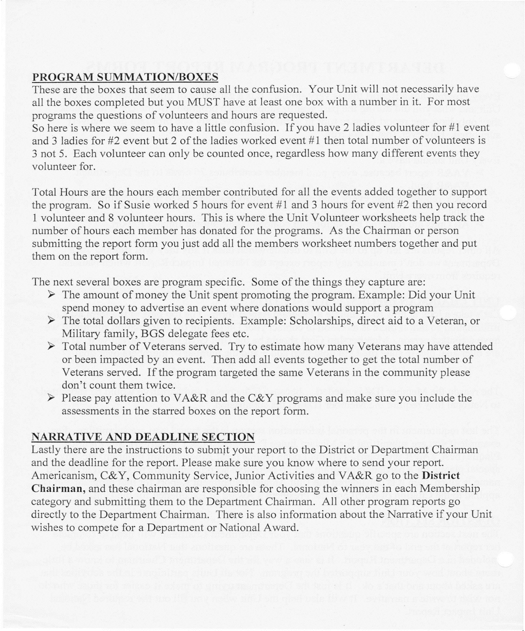

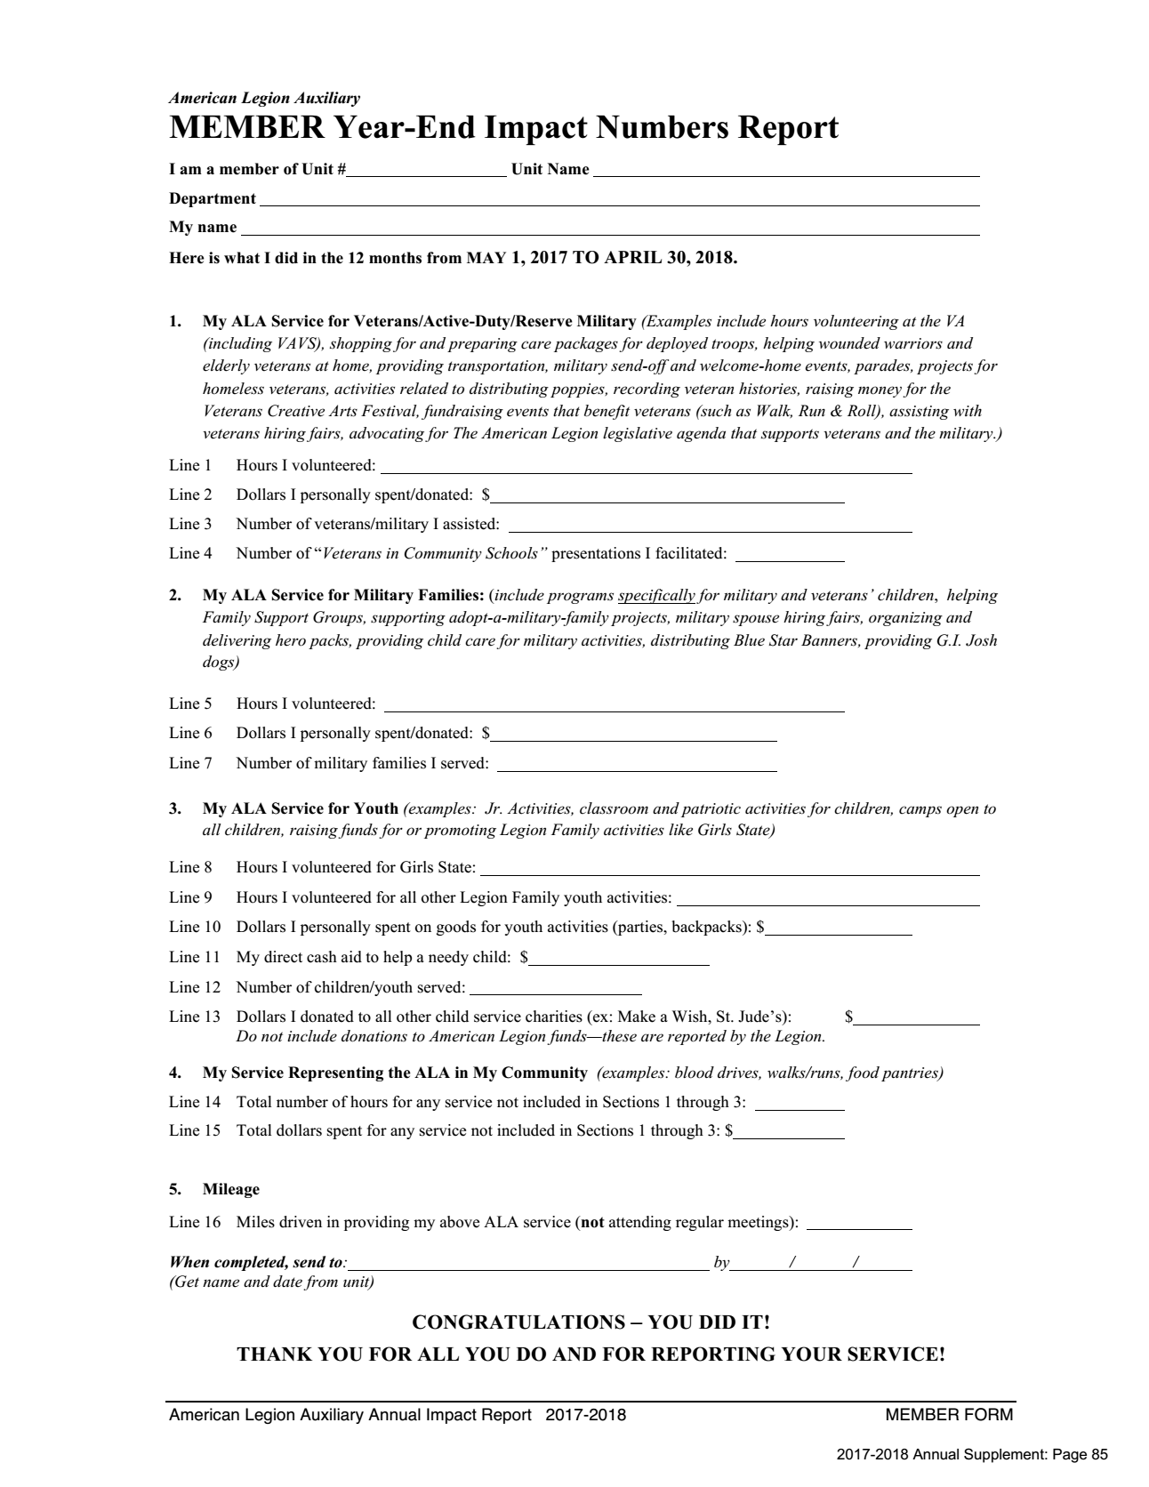
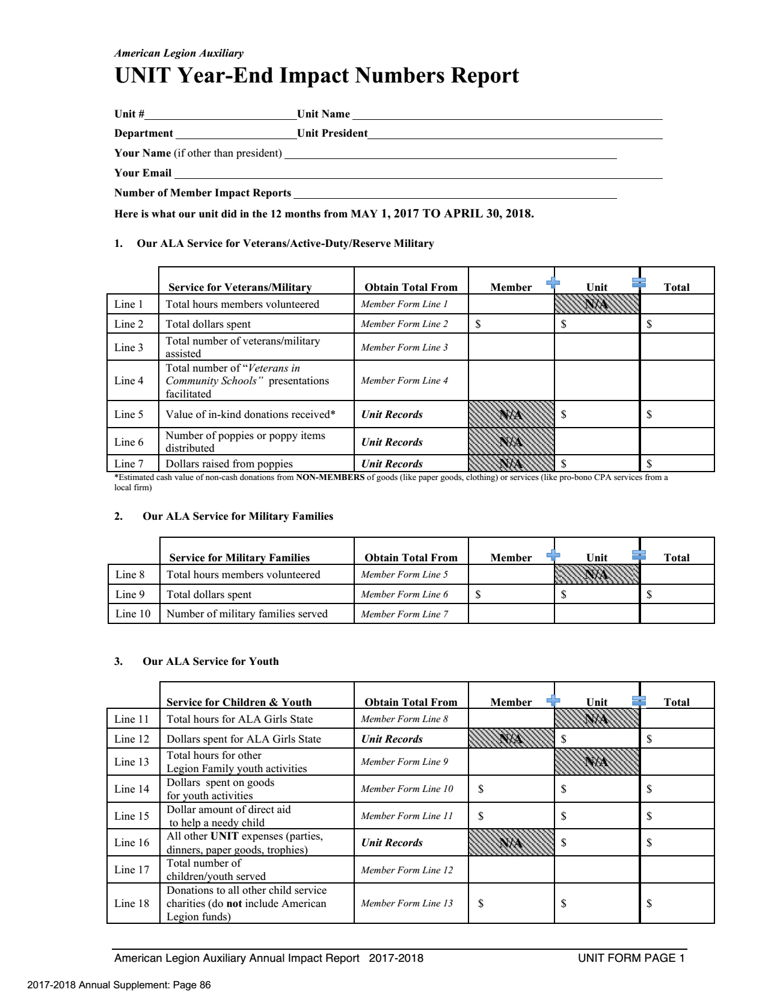
SEND TO UNIT PRESIDENT
BY APRIL 15th, 2018

SEND TO DISTRICT PRESIDENT
BY MAY 1, 2018
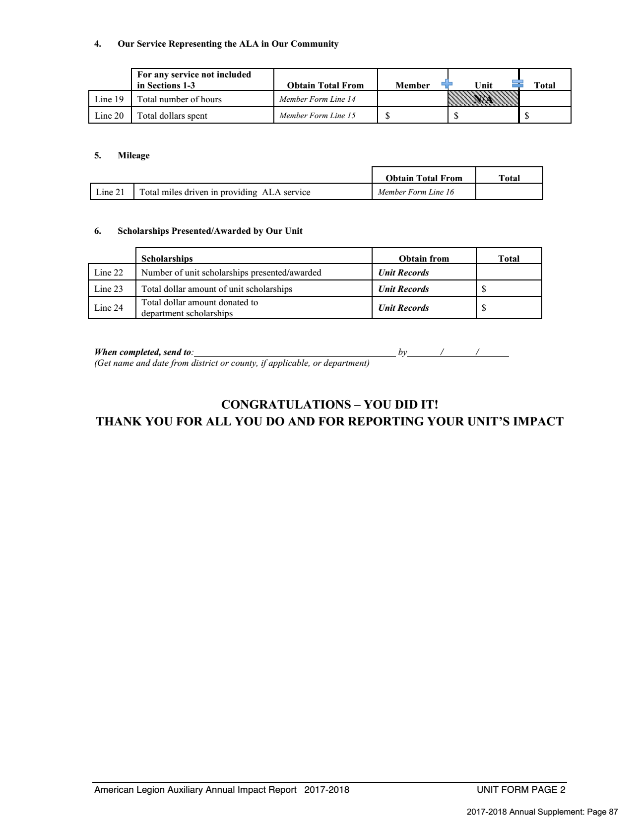
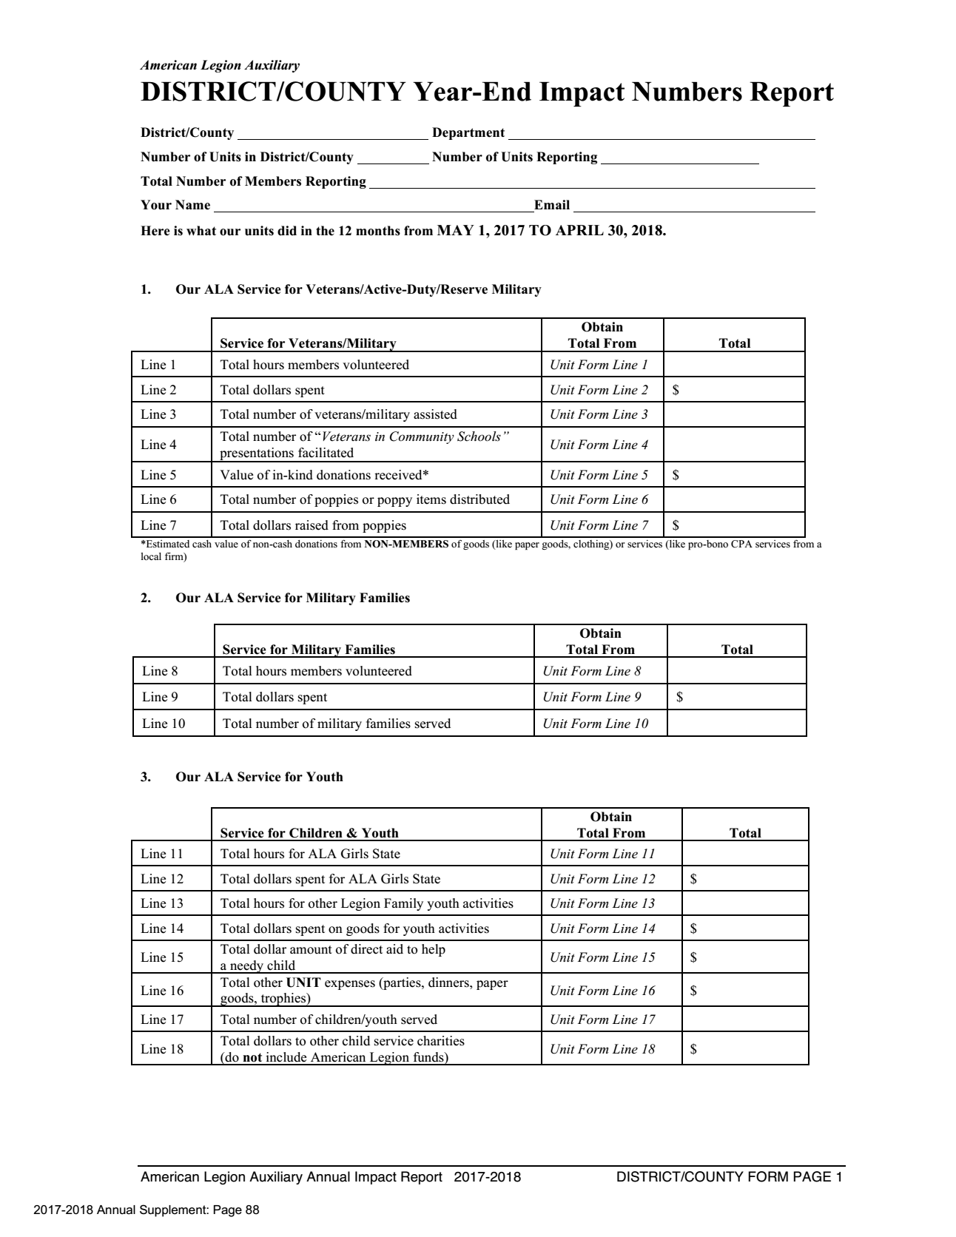
SEND TO DEPT SECRETARY
BY MAY 15, 2018

