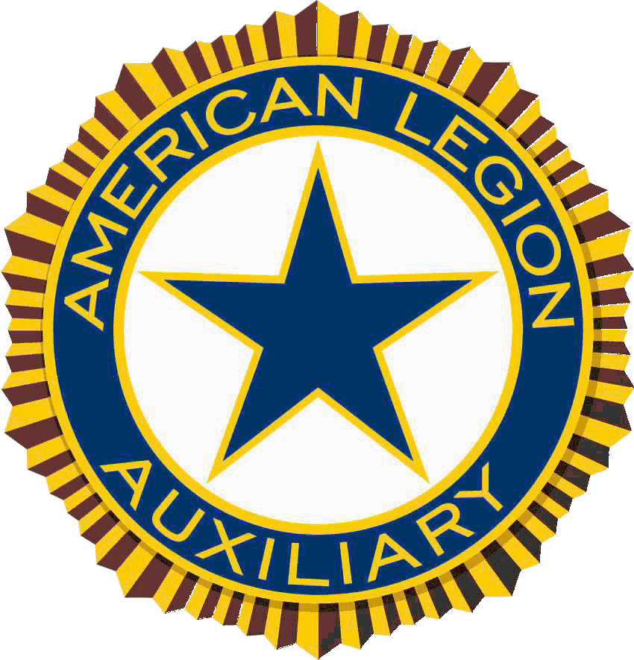

**MID-WINTER**

**CONFERENCE**



**Crown Plaza Columbus North**

**January 19-21, 2018**

* **Leadership Workshop “Tool Kit For Success”**

**January 19th, 2-4pm**

* **Buckeye Girl State Information Session for Legion & Auxiliary**
* **January 19th @ 4pm (no registration necessary)**
* **Legislative & Nat’l Security Awareness Assembly with Guest Speakers – January 19th @ 630 pm**
* **Juniors Meeting – January 19th & 20th**
* **Program Information and Reporting**

**– January 20th @ 9am**

* **National Commander’s Banquet**

**– January 20th @ 7pm**

* **Cut Off to Make Hotel Reservation – December 23rd, 2017**



The American Legion Auxiliary Department of Ohio Mid-Winter Conference will be held January 19 & 20, 2018 at the Crowne Plaza Columbus North, 6500 Doubletree Avenue, Columbus, Ohio.

There are many exciting things planned for the upcoming Mid-Winter Conference. You’ll hear from the Department Chairmen will have plenty of brochures and information regarding their programs at the exhibit tables on Friday evening and Saturday morning.

There will two workshops on Friday afternoon. A Leadership workshop, **“Tool Kit for Success,”** where you will received information on; How to write a narrative; Basic protocol/conduct in a meeting; and the importance of Goodwill. Attendees should bring one question for discussion on leadership from the Plan of Action. A **Buckeye Girls State Information Session** will also be given to Units and Posts seeking more information about the process for selecting delegates, communicating with the high school, fund raising strategies, and the application process.

Friday evening’s session will open at 6:30 pm. There will be special focus on National Security/Legislative Awareness. A very informative program planned for Friday evening with presentations on the Legion’s Legislative Agenda & information from one of Ohio’s Legislative Representatives. Saturday we’ll have a special presentation and honor our VA Representatives from all the VA Hospitals. Remember to bring your Poppy Usage Contest entry, they will be on display Friday and Saturday for you to vote on. Saturday evening there will be a Commander’s Banquet with the National Commander.

The Juniors will meet on Friday evening and Saturday, so plan on bringing your Juniors.

For housing reservations, please call (614) 885-1885, Pick option 2 or (800) 996-8916 and refer to the American Legion Group. Rooms are $93.00 plus tax. Reservations must be made by **December 23, 2017**. Cancellation of any reservation must be made 48 hours prior to arrival date and confirmed by the hotel cancellation number.

Please plan to attend, enjoy the fun and fellowship, and learn more about the programs of the American Legion Auxiliary.

**MID-WINTER**

**CONFERENCE**

**LEADERSHIP WORKSHOP – “Toolkit for Success”**

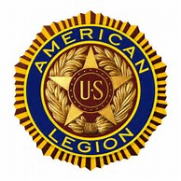

**Workshop Registration Form**

**$5.00 for each attendee**

**Mail to Department of Ohio**

**PO BOX 2760**

**Zanesville, Ohio 43702**

**Unit_________________________________District _____________**

**Name____________________________________________________**

**Name____________________________________________________**

**Name____________________________________________________**

**Name____________________________________________________**

**Total Amount Registration Fee_____________________**

**Friday, January 19th  2-4 pm**

**Register to Attend**

**$5.00 per attendee**

**Email:** [**katie@alaohio.org**](mailto:katie@alaohio.org)

**with the Unit # District #**

**& Names of Attendees**

**National Commander’s**

**American Legion Family Banquet**

**Commander’s Membership Banquet Ticket Form**

**Name____________________________________________**

**# of Tickets Beef___________ Chicken_______**

**@ $30.00 per person**

**Amount Enclosed $________________________________________________**

**Send to ALA Department of Ohio, PO BOX 2760, Zanesville, Ohio 43702**

**The National Commander’s Membership Banquet is a Formal Banquet Hosted by the Department of Ohio for the National Commander to present Membership Awards to all mid-year winners.**

**Auxiliary Members are encouraged to attend. District Presidents will be recognized for their efforts in Membership and their efforts in support for the Military Family Assistance Fund.**

**Dress is Semi-Formal**

**Reservations Cut Off: January 12th 2018**

**Cost is $30.00 per person**

**Saturday, January, 20th 2018, 7pm**

**Crowne Plaza Columbus North**

**Mid Winter Housing**

***6500 Doubletree Ave***

***Columbus, Ohio 43229***

***By Phone (614) 885-1885 or (800) 996-8916***

***Select Option #2***

**Please call for reservations and refer to the AML**

Be sure to ask for a confirmation number and if you need to cancel, please secure a cancellation number.

***Single or Double - Price: $92.00 +16.75% Tax ($15.41) = $107.41***

***Reservation Cut-Off Date – Wednesday, December 20, 2017***

**Check-in time is 4:00 PM and checkout time is 12:00 PM. The hotel will assess a $25.00 late checkout fee to those who choose to checkout after 12:00 PM.**

**The Crowne Plaza Columbus North has a 100% Non-Smoking Policy, which includes all guest rooms, restaurants, lounges, meeting rooms, public space, and employee work areas. There will be a $250.00 recovery fee for guests who do not comply.**

Directions from I-71: Take the Route 161 Exit #117. Turn West onto Route 161. Turn right on Busch Boulevard. Go three (3) traffic lights to Kingsmill Parkway and turn right. Kingsmill goes directly into the Crowne Plaza Parking Lot.



**MID-WINTER**

**CONFERENCE**



**Crown Plaza Columbus North**

**January 19-21, 2018**