

### AMERICAN LEGION AUXILIARY

**Department of Ohio, Inc.**

**PO Box 2760**

**Zanesville, Ohio 43702-2760**

**(740) 452-8245**

#### Phone – (740) 452-8245

##### Fax – (740) 452-2620 E-Mail – heather@alaohio.org

**Website - www.alaohio.org**

**ALL MEMBERSHIP FORMS ARE AVAILABLE ON THE DEPARTMENT WEBSITE!!**

To: Unit Membership Chairmen

From: Department Headquarters and Heather Wilson, Membership Clerk

**SUBJECT: ONLINE DUES PAYMENT PROCESS**

**IMPORTANT!!!** **IF YOU ARE NOT THE PERSON WHO WILL BE HANDLING THE 2021 MEMBERSHIP DUES FOR YOUR UNIT, PLEASE PASS THIS LETTER ON TO THE PROPER PERSON.**

The purpose of this letter is to inform you and your Unit of the NEW Online Dues Payments process, beginning November 2020. All Online Dues Payments we receive from National via your members will be processed, a receipt will be issued where the Unit will be credited the amount of the Unit’s portion. Because of the positive response and the increase of members paying their dues online, the Department finds itself issuing a much larger amount of checks. Some checks are in the amount of $3.00 or less. This has increased the cost of processing at the Department. Therefore, the Unit will now see a credit on their receipt with the name and the amount that was credited their account. Very similar to how it has been conducted previously, the only difference is that the Unit will not receive a check, instead they will receive a credit.

Credits can be used at any time for membership payment. If the Unit wishes to have a credit check issued, we will do so during the month of August. We must have received your credit request by June 30th. (See the Attached Form).

If you have any questions please feel free to call myself or any member of the Department Staff.

**Kind Regards**

**Heather Wilson, Membership Clerk**

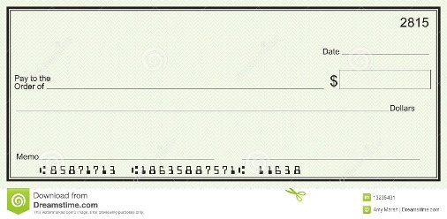

**CREDIT**

Unit Check Request Form

FOR UNIT MEMBERSHIP CREDIT

Dept. HQs

Your Unit

UNIT NUMBER_______________________________________________

UNIT NAME____________________________________________________

UNIT MEMBERSHIP CHAIRMAN________________________________________________

ADDRESS WHERE CHECK IS TO BE SENT ______________________________________________________________________________

______________________________________________________________________________

______________________________________________________________________________

Unit #___________ requests a check be issued for the full amount of our Unit’s Membership Credit and be sent to the address listed above.

Please issue the check in the total amount of __$________________________.

DATE________________________________________________

SIGNATURE OF UNIT MEMBERSHIP CHAIRMAN

Credits can be used at any time for membership payment. If the Unit wishes to have a credit check issued, we will do so during the month of **August.** We must have received your credit request by **June 30th.** **If we do not receive your request for a check by the deadline, then your credits will be carried over into the next fiscal year.**

**FOR OFFICE USE ONLY**

DATE CHECK ISSUED: ________________________________________________

AMOUNT CHECK: ___________________________ CERTIFIED BY: ________