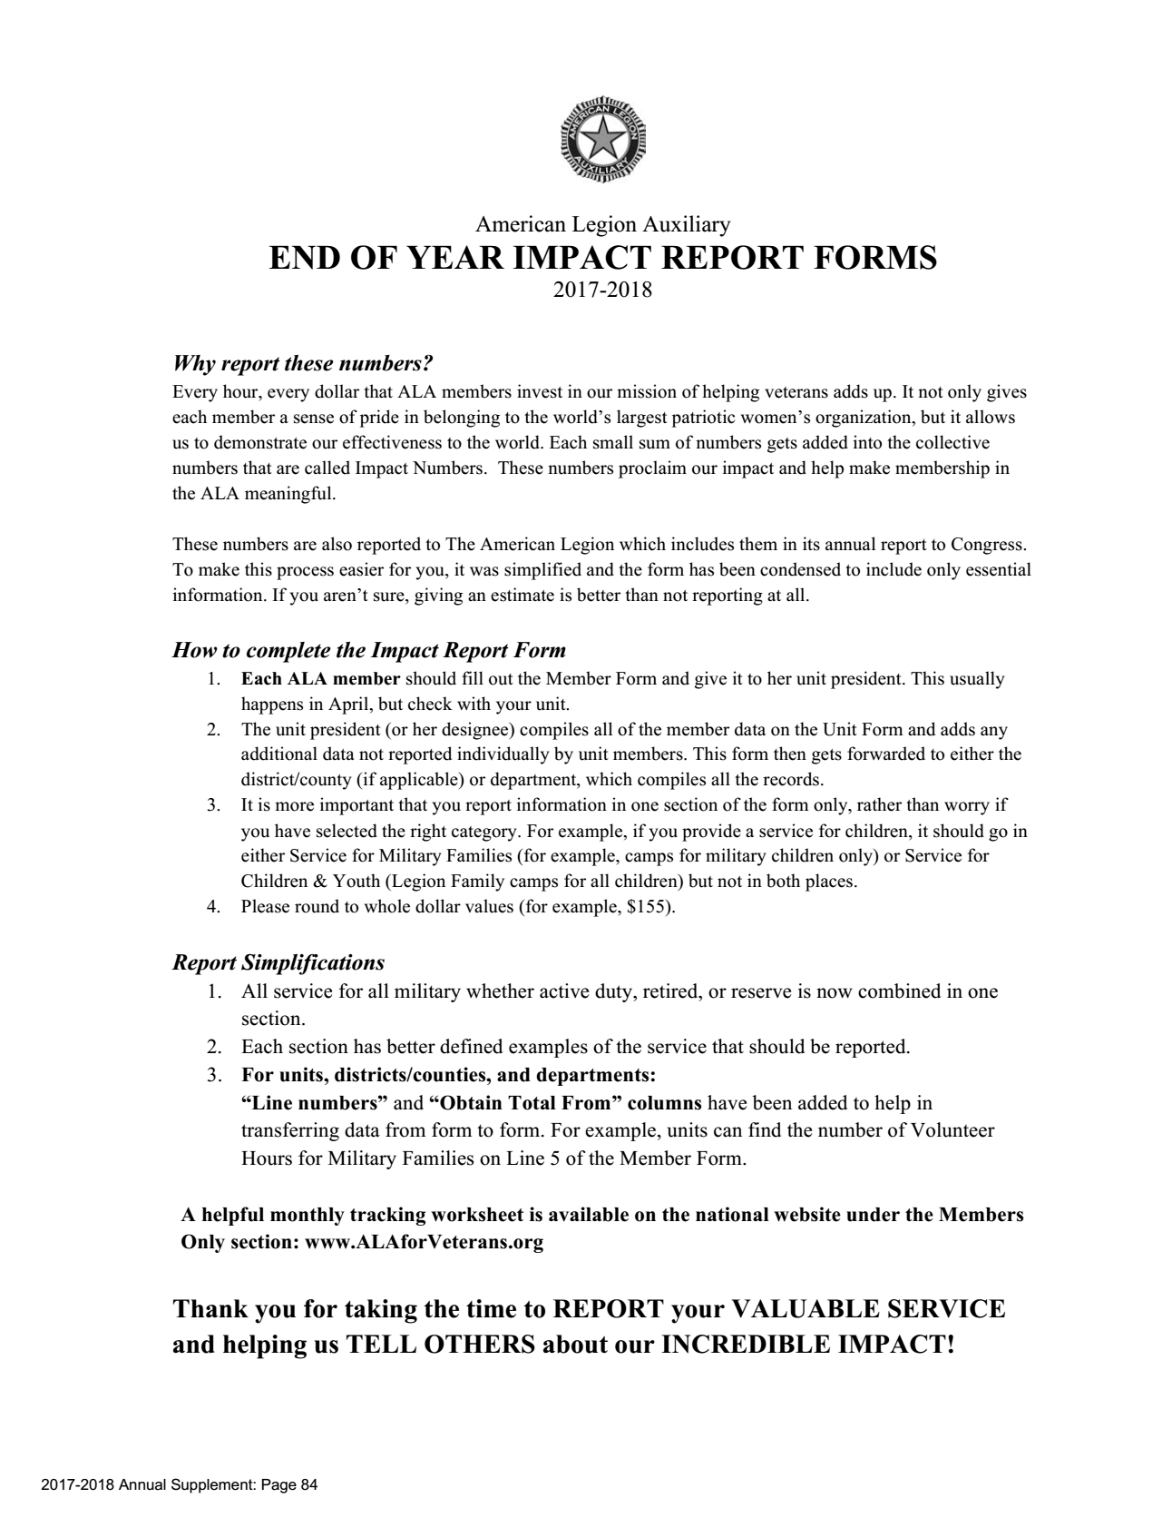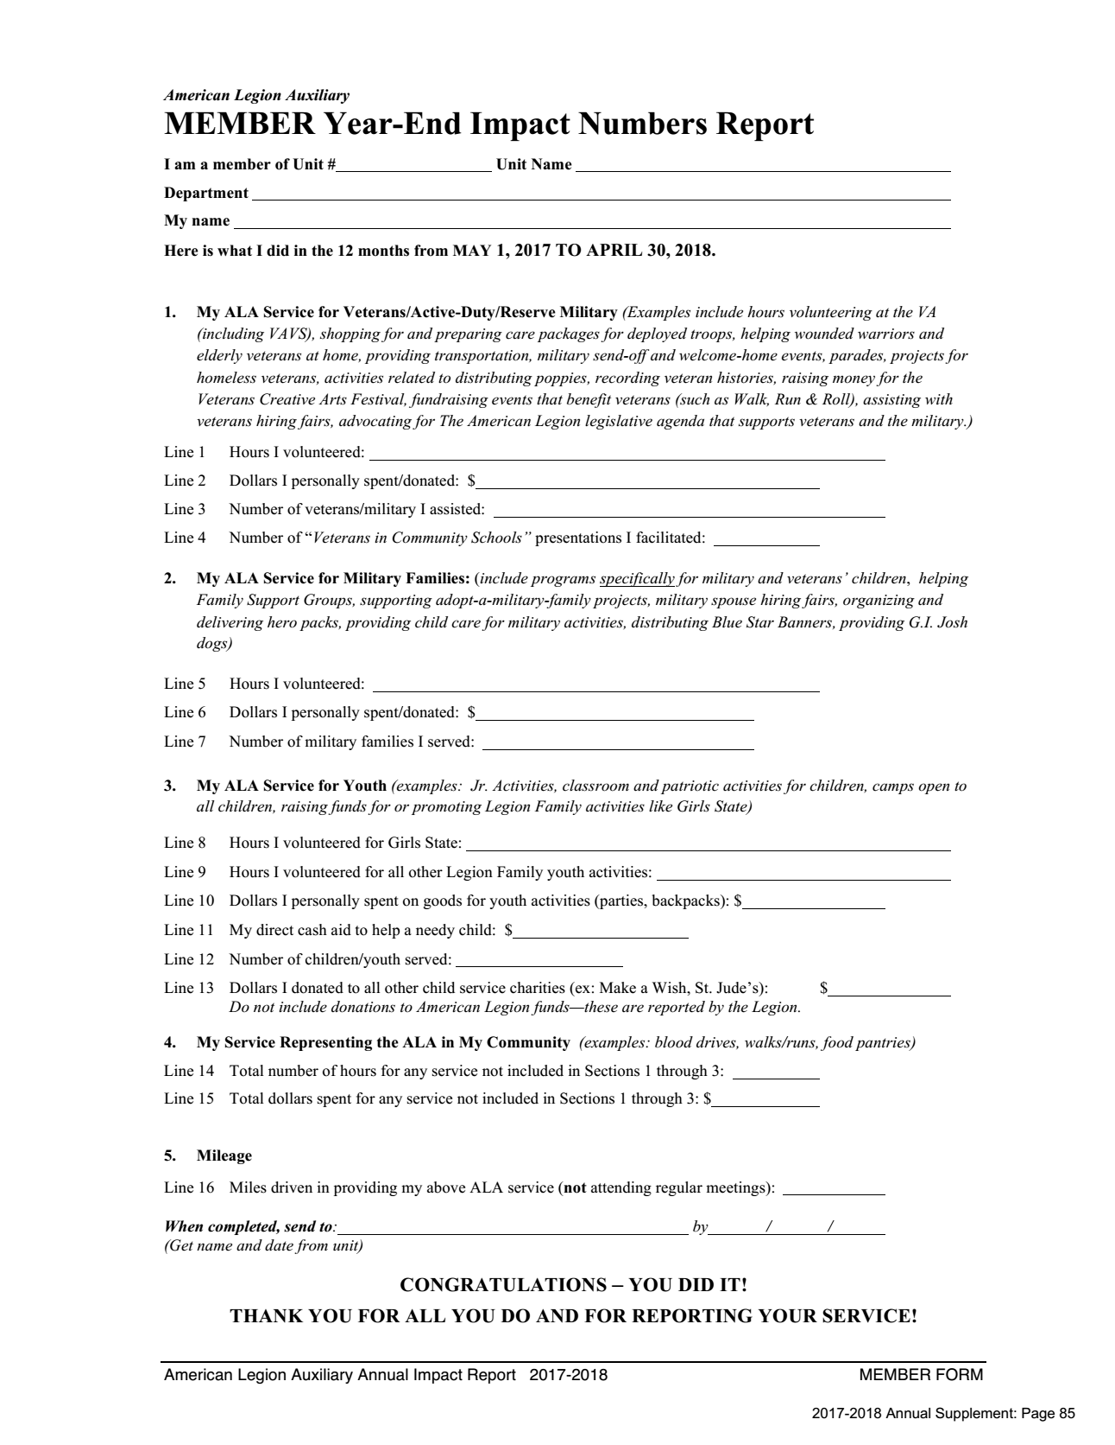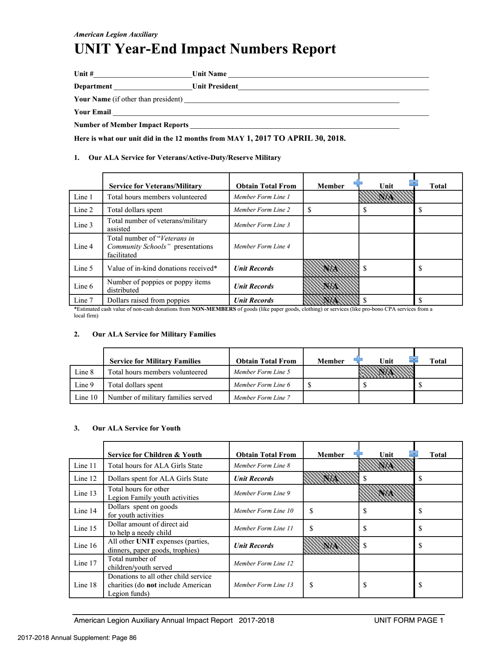

**SEND TO UNIT PRESIDENT**

**BY APRIL 15th, 2018**



**SEND TO DISTRICT PRESIDENT**

**BY MAY 1, 2018**

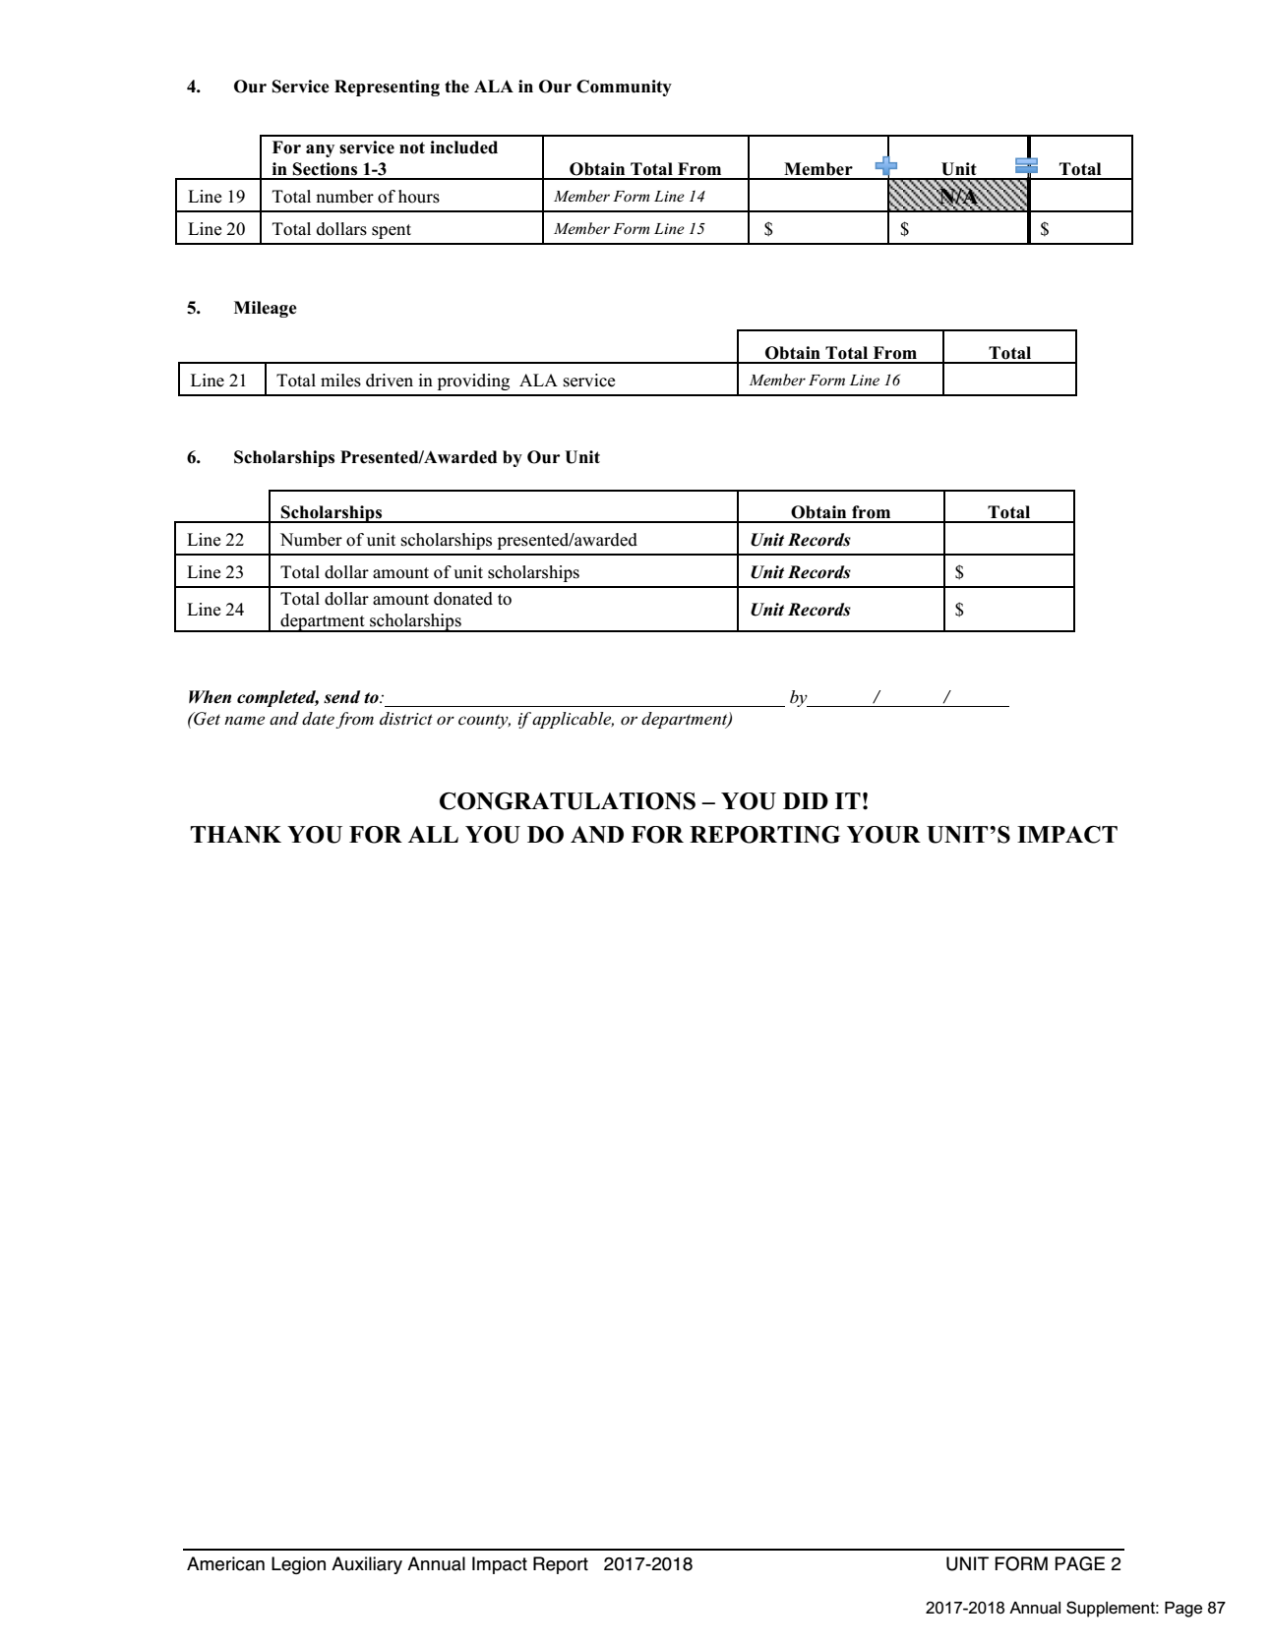

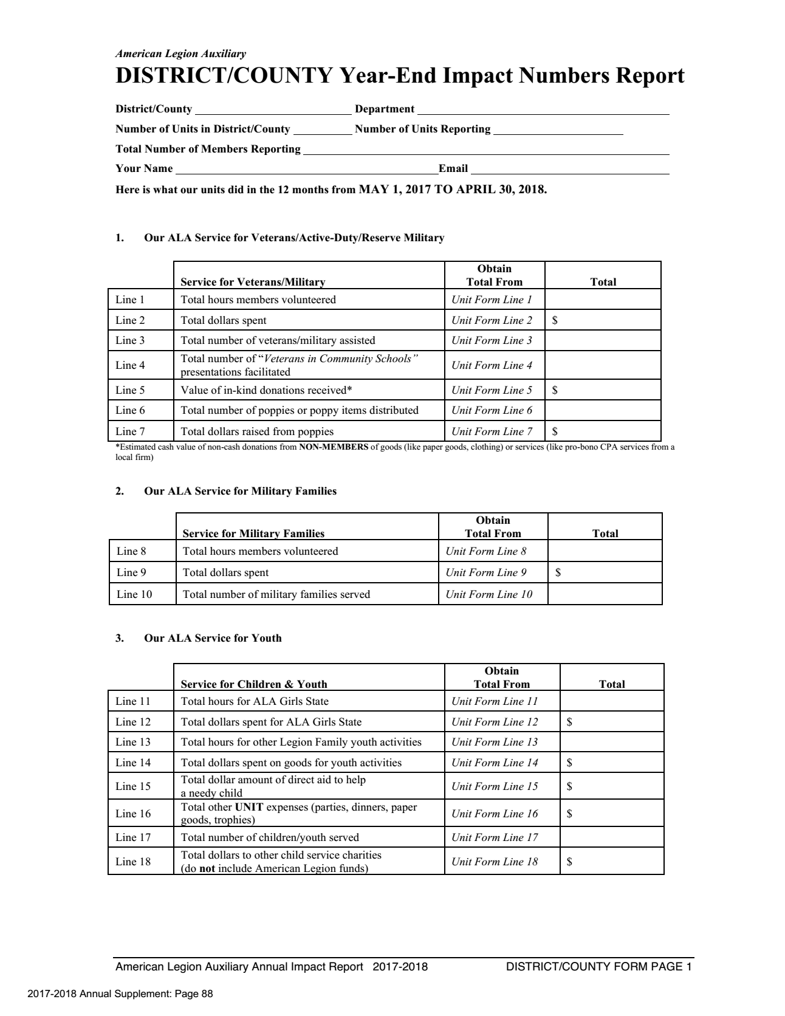

**SEND TO DEPT SECRETARY**

**BY MAY 15, 2018**

