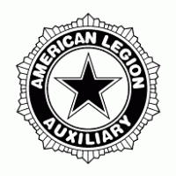**HISTORY**

|  |
| --- |
| **HISTORIAN** |
|  |
| Dayna Beyer |
| 6013 Garber Road |
| Bellville, Ohio 44813 |
| (419) 566-9395 (cell)  (888) 225-3180 (fax) |
|  |
| Email – mrsdaynabeyer@gmail.com |
|  |
| **REPORT DUE:**  **April 15, 2022** |





**Answer the following Questions in your narrative.**

Narrative must be typed written in narrative form.

Narrative must not exceed 1,000 words. (Can be fewer words if program dictates)

Narrative may include photographs and news articles.

* How many senior and junior members and volunteers helped serve and/or participate in the year’s activities and events? Give a brief description of the kinds of activities and events that were had. ____ _________________________________________________________________________________________________________________________________________________________________________________________________________________________________________________________
* How many veterans were served and how many patriotic activities and events were planned and or presented. Select two activities or events that were most memorable and showed the spirit of serving and write a short story on them. _________________________________________________________ _________________________________________________________________________________________________________________________________________________________________________________________________________________________________________________________
* Share a story that involved members being installed or a special presentation during a unit meeting with a guest speaker or special ceremony or recognition of an auxiliary member. ______________________ _________________________________________________________________________________________________________________________________________________________________________________________________________________________________________________________
* What was the total amount of funds raised from all activities and events? How and where were the funds distributed i.e., presented by check or in person and to what program and or charity? __________ ______________________________________________________________________________________________________________________________________________________________________
* How much was the cost/spent and donated to do the programs, activities, and events? ______________ ___________________________________________________________________________________
* Did your unit interview, video tape and post on You Tube and the ALA National History Facebook page senior and junior members stories for the “Members Remember Project”. Please elaborate on what was learned about your member(s). ______________________________________________________ _________________________________________________________________________________________________________________________________________________________________________________________________________________________________________________________
* How is your unit archiving their history? Are you incorporating the unit’s history into a Cavalcade of Memories to show other members and the public on the unit’s service in the community? Consider having an open house and invite inactive members and the public for a tea to share with them the past history gathered in the cavalcade. _______________________________________________________ _________________________________________________________________________________________________________________________________________________________________________________________________________________________________________________________
* Who was the honored veteran interviewed for the Veterans Service Project by your junior member(s)? Summarize what was learned about the veteran’s service i.e., when and where he served, his or her branch of service, and was the entire package submitted to Washington DC Library of Congress. Share a brief summary story on LegiontownUSA. _______________________________________________ _________________________________________________________________________________________________________________________________________________________________________________________________________________________________________________________
* What was the significant goal that the woman veteran or non-veteran achieved and what was learned about her during Women History Month of March? Submit your story to Facebook and to the American Legion Auxiliary Magazine. ___________________________________________________________ _________________________________________________________________________________________________________________________________________________________________________________________________________________________________________________________
* What was your goal quota membership, and did you reach goal? Any new or old members you would like to highlight? ____________________________________________________________________ _________________________________________________________________________________________________________________________________________________________________________________________________________________________________________________________

**MAIL TO DEPARTMENT HISTORIAN**

Dayna Beyer

6013 Garber Rd.

Bellville, OH 44813

**HISTORY**

**Key Program Statements:**

* The heart of any organization’s history is in its records – items that officers, members, directors, staff, and volunteers have produced and compiled over the years. They provide unique testimony to the achievements of an organization.
* Maintaining and preserving our records are invaluable to society by serving as informative and educational resources to a variety of potential users. In other words, an organization benefits itself and the public by preserving its records and making them available for use by everyone inside and outside the organization.
* Members are able to look back and learn what efforts were successful, or unsuccessful, and why. Understanding the missteps as well as the achievements can assist in determining a stronger future strategy.

1. **Objective Goal:** The heart of the organization – your Unit members – who they are and how they have served.
2. **Action Step:** Have each officer or member provide a biography of themselves, (i.e. how they are eligible to be a member, how many years as a member, what offices they have held and what is their “why” they are involved with the organization).
3. **Action Step:** Take a photo of each officer and with their “bio” post it on social media, at your post/unit and publish it in your local paper to introduce them to the community. Archive it in your records.
4. **Objective Goal:** Maintaining and preserving Unit records – Keep good records, update yearly with minutes, newspaper clippings, POA’s and awards.
5. **Action Step:**  Know where your Unit records are and that they are in a safe accessible location.
6. **Action Step:** Update your records monthly, quarterly, or annually or based on your Constitution & Bylaws. Create a digital record for additional safekeeping.
7. **Objective Goal:** Every effort matters as we learn from them, whether successful or not, as it will help us moving forward in our future achievements.
8. **Action Step:** At each meeting, ask your members about the most recent or last event – list what worked and what did not work.
9. **Action Step:** Have a discussion on how the event could be improved or new ideas for another event. Keep this information in your history journal that can be shared and archived.

**HISTORY RESOURCES**

* Historians National Facebook page: <https://www.facebook.com/groups/ALAHistorians/>
* ALA National website: <https://member.legion-aux.org/member/committees/history>
* Veterans History Project, Library of Congress: <https://www.loc.gov/vets/kit.html>
* Legiontown USA: <http://www.legiontown.org/share>
* American Legion Auxiliary Magazine: <https://www.legion-aux.org/magazine>

**Year-End Reports**

Annual reports reflect the program work of units in the department and may result in a national award for participants if award requirements are met. Each Unit Historychairman is required to submit a narrative report by **April 15, 2022,** to the Department Historian, Dayna Beyer, 6013 Garber Rd., Bellville, Ohio 44813.

**DEPARTMENT AWARDS & DEADLINES**

1. Certificate(s) of Achievement will be awarded to the Unit submitting the best annual narrative report.

2. Certificate(s) of Achievement will be awarded to the Unit submitting the best History Scrapbook.

3. Certificate(s) of Achievement will be awarded to the Junior submitting the best History Scrapbook.

4. Certificate(s) of Achievement will be awarded to the Junior submitting the best Junior History.

5. Plaque will be awarded to the Unit with the best all-around Senior History.

**Rules For Senior History Narrative**

**I.** **INTRODUCTION (10 POINTS)**

(This section should be single spaced and centered in the middle of the page.)

**A.** Title Page

i. History of Unit Number _______

ii. District number

iii. Name of Unit Historian

iv. Date: 2021 – 2022

B. Forward or Dedication

C. Picture of Unit President (optional)

D. Prayer

E. Pledge of Allegiance

F. First verse of “The Star Spangled Banner”

G. Preamble to the Constitution

**II. HISTORICAL (70 POINTS)**

A. List of all elected officers with names

B. List of all appointed officers with names

C. List of all chairmen with names

D. The history should be written as factual narrative beginning with the installation of officers and ending with the summary of end-of-year reports and closing events for the administrative year.

E. The signature of the Unit Historian shall immediately follow the last paragraph.

F. Index (optional)

**III. APPEARANCE (10 POINTS**

A. Cover: binder for loose-leaf paper, preferably blue, with 2½” gold foil American Legion Auxiliary Seal centered on the cover or a regulation binder with imprinted seal.

B. Paper: plain 8 ½” x 11”

C. Page Setup:

i. Margins should be set as follows: left and right margins should be 1.25”; top and bottom margins should both be 1”.

ii. Page numbers should begin on the first page of the Historical Content. They should be centered and placed 0.5” from the bottom.

D. Spacing: **Double-spaced,** with the exception of the introductory pages (Title Page, Forward or Dedication, Photograph of Unit President, Pledge of Allegiance, “Star Spangled Banner”

and Preamble), which shall be centered in the middle of the page. Paragraphs may be indented or in block form.

E. Text: 12-point font, Times New Roman or Arial style font. Black type only.

i. Technology: Computer preferred however a typewritten or handwritten history is permissible. If typewritten or handwritten, the page set up should not vary from what is required of computer users.

**IV. ARRANGEMENT (10 POINTS)**

A. Written in narrative form in the third person.

B. Clear, concise language with correct spelling.

C. No decorations, computer graphics, pen or ink drawings, illustrations, extra materials, photographs, newspaper articles and/or clippings.

D. Be original and unique in thought and presentation.

**V. DEADLINE: HISTORY NARRATIVE MUST BE RECEIVED BY APRIL 15, 2022**

Send your History Narrative to: Department Historian, Dayna Beyer, 6013 Garber Rd., Bellville, Ohio 44813

**Rules For Junior History Narrative**

**I. INTRODUCTION (10 POINTS)**

A. Title Page

i. History of Junior name and number of Unit Junior Group

ii. Name and address of Junior

iii. Date: 2019 – 2021

B. Forward or Dedication

C. Picture of Honorary Junior President (Department, District and/or Unit)

D. Prayer

E. Pledge of Allegiance

F. First verse of “The Star Spangled Banner”

G. Preamble to the Constitution of the American Legion Auxiliary

**II. HISTORICAL CONTENT (70 POINTS)**

A. List of elected or appointed Honorary Junior Officers 2021-2022

B. List of Honorary Junior Unit Chairman or committee appointments held by your Unit 2021 – 2022

C. The history shall be written as factual narrative, beginning with the installation of 2021 – 2022 Junior Unit officers and ending with the summary of end-of-year reports and closing events of the administrative year.

D. The signature of the Junior is to immediately follow the final paragraph of the history.

E. Index (optional)

**III. APPEARANCE (10 POINTS)**

A. Cover: binder for loose-leaf paper, preferably blue or red, with 2 ½” gold foil American Legion Auxiliary Seal centered on the cover or a regulation binder with imprinted seal.

B. Paper: Plain white 8 ½” x 11”.

C. Page Setup:

i. Margins for left and right margins should be 1.25”; top and bottom margins should be 1”.

ii. Page numbers should begin on the first page of the Historical Content. They should be centered and placed 0.5” from the bottom.

D. Spacing: **Double-spaced,** with the exception of the introductory pages (Title Page, Forward or Dedication, Photograph of Honorary Junior President (Department, District and/or Unit), Pledge of Allegiance, “Star Spangled Banner” and Preamble), which shall be centered in the middle of the page. Paragraphs may be indented or in block form.

E. Text: 12-point font, Times New Roman or Arial style font.

F. Technology:

i. Computer preferred, but not necessarily in the third person

ii. Clear, concise language with correct spelling.

iii. No decorations, computer graphics, pen or ink drawings, illustrations, extra material or newspaper clippings.

iv. Be original and unique in thought and presentation.

**IV. DEADLINE: JUNIOR HISTORY NARRATIVE MUST BE RECEIVED BY APRIL 1, 2022.**

Send your Junior History Narrative to: Department Historian, Dayna Beyer, 6013 Garber Rd., Bellville, Ohio 44813

**Senior Unit Scrapbook Contest**

Document and submit a narrative on your Unit’s events and activities. Display your “Service Not Self” by putting together a scrapbook with photos, programs, and newspaper articles that your Unit can look at for years to come. Don’t forget to have your Juniors write about their history, events, and activities. The rules for all of these submissions are included in this Ohio Unit Plan of Action. Please make sure you follow all deadline dates.

**Rules For Senior Unit Scrapbook Contest**

**I.** **CONTENT**

A. Title Page

i. “Scrapbook of Unit (Number, Name, District)”

ii. Name and Address of Unit Historian

iii. Date: 2021 – 2022

B. Chronological History

i. Pictures (brief captions and dates) of Officers and Chairmen

ii. Pictures (brief captions and dates) of Unit activities

iii. Newspaper articles

iv. Programs

**II.** **FORMAT**

A. Red or blue notebook with paper size of 8 ½ x 11 inches or larger

B. Typewritten, word processor or computer may be used

C. “Scrapbook” should appear on front cover

D. Signature of entrant

**III.** **DEADLINE: SCRAPBOOKS MUST BE RECEIVED BY APRIL 15, 2022**

Send your Scrapbook to: Department Historian, Dayna Beyer, 6013 Garber Rd., Bellville, Ohio 44813

**Rules For Junior Scrapbook Contest**

**I.** **CONTENT**

A. Title Page

i. “Scrapbook of (Junior Name, Unit Number and District)”

ii. Name and Address of Junior

iii. Date: 2021 – 2022

B. Chronological History

i. Pictures (brief captions and dates) of Officers and Chairmen (can be Department, District and/or Unit)

ii. Pictures (brief captions and dates) of activities Junior was involved in.

iii. Newspaper articles

iv. Programs

**II.** **FORMAT**

A. Red or Blue notebook with paper size of 8 ½ x 11 inches or larger

B. Typewritten, word processor or computer may be used

C. “Junior Scrapbook” should appear on front cover

D. Signature of entrant

**III. DEADLINE: SCRAPBOOKS MUST BE RECEIVED BY APRIL 1, 2022**

Send your Junior Scrapbook to: Department Historian, Dayna Beyer, 6013 Garber Rd., Bellville, Ohio 44813

**HOW TO RECORD AND POST TO "MEMBERS REMEMBER"**

Committee: History

Contact Information for Questions: History @ALAforVeterans.org

Objective: Record the ALA's history through the eyes of its members

Background Information

The history of the American Legion Auxiliary begins back in November 1919 and continues with you. The organization's history, like any other history, is more than names and dates. It is about its membership and how it developed the ALA's programs and projects to fulfill our mission of serving the veterans, servicemembers, and their families who sacrifice much for this country of ours.

A written history can only tell so much. However, when an organization 's history is told through the eyes of its membership, everyone learns a great deal more about who we are, what we do, and why we matter.

Step-by-Step Instructions Here are some tips:

* This is a two-person project so find someone to assist. This is a good time to enlist the help of your 9th -12th grade Junior members as it is a required activity in earning the History Patch. If your unit does not have Junior members, enlist the assistance of college students.
* Find longtime members of the Auxiliary and ask them to share their stories in a video.

These stories can be about:

* A special project,
* A particular highlight during her membership
* How many generations of her family have been members and why  If a chartered member, her experience in starting the unit
* Find a location where it is quiet and where there will be no interruptions.
* Record with iPhones/Smartphones. Please keep in mind that your video file must be either a .mov; .avi; .mpeg; or a .wmv file extension.
* Each recording should be no longer than five (5) minutes long. You may make more than one. Cover one topic in each video.
* Post the video on YouTube. An instructional video on how to upload is located at www.youtube.com/watch?v=_07iUiftbKU.
* Go to YouTube at https://www.youtube.com
* Give the video the following title: ALA Dept. of _ (two letter abbreviation for your state) Unit Members Remember.
* Provide a description and tags that will help people locate the video easily,  Under Category, click on Nonprofits & Activism.  Under Privacy,_ click on Share your video with the world.
* Click Save Changes,

**HOW TO INVOLVE A JUNIOR MEMBER**

Committee: History

Contact Information for Questions: History@ALAforVeterans.org

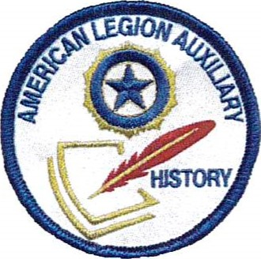

Objective: Help a Junior member (9th — 12th grades) earn the new History Patch

Background Information

In a joint effort with the National Junior Activities Committee, we have developed a History Patch for our high school (9th — 12th grades) Junior members. These young ladies have an opportunity to work with, learn from, and take ownership of the American Legion Auxiliary history. It is important for them to understand that they are a part of the Auxiliary's history. By earning this patch, they may become interested not only in the history itself, but in preserving it as well, and become a unit's or department's History/Cavalcade chairman.

Step-by-Step Instructions

What can we do?

* Contact the department Junior Activities chairman and ask her to help promote this new patch. Make joint announcements at your fall/winter/spring meetings , division/district meetings, etc.
* Write an article about the patch for the department newsletter.
* Make a poster to promote the patch for meetings. Include the patch and activities list (see below).
* Encourage the unit History/Cavalcade chairmen to promote this patch and work with their unit Junior Activities committee chairman.
* Find a high school aged Junior member and be a mentor to her as she works the activities to earn the patch.

**HISTORY PATCH BLUE LEVEL 3**

**(Grade 9th-12th)**

Educate yourself about the history of the ALA and The American Legion Family Level 3: Twelve (12) possibilities; Three* (3) activities are required; Six (6) are your choice. A total of Nine (9) activities must be completed from the Twelve (12) choices.

|  |  |  |  |
| --- | --- | --- | --- |
| No.: | Activity: | Date: | Adult Signature: |
| *I | Interview at least two ALA members for the Members Remember project. Post your video interviews on YouTube.com. Information can be found on the National History Committee page of the Members Only section at www.ALAforVeterans.org. |  |  |
| 2 | Learn about the Veterans History Project. Interview at least two veterans and preserve their stories. Send your project to the Library of Congress www.10c.gov/vets. |  |  |
| 3 | Contribute to your unit's ALA Senior History Book. Focus on who we are, what we do and why it matters. |  |  |
| *4 | Contribute to your unit's ALA Junior History Book. |  |  |
| 5 | Contribute to and/or start a unit history museum to capture the impact the ALA has had on your community. |  |  |
| *6 | Research and do a presentation on the history of your unit. Present it to your Junior unit, or at a unit or post meeting, |  |  |
| 7 | Research current, former or deceased members of your Legion Family (unit, post or squadron) who made a significant contribution to your community. |  |  |
| 8 | Organize a Veterans in Community Schools presentation. Work with a veteran in your post, and find a school or classroom in which to make a presentation. |  |  |
| 9 | Organize a library of past issues of Auxiliary magazine for your unit. Make special notation of issues with articles relevant to your unit or department. |  |  |
| 10 | Start a Blue Star/Gold Star Mothers and Families database for your unit. |  |  |
| 11 | Start an ALA Girls State database for your unit: who your unit sponsored, what offices the girls held, and if anyone went on to ALA Girls Nation. |  |  |
| 12 | Start a Poppy Program History: Keep track of your unit's Poppy Poster Contest, Miss Poppy, and Little Miss Poppy winners. Make special notation of those who also went on to win at the department or national level. |  |  |
|  | Name of Junior Member:  Grade: _________ Unit #: ___________ |  | Department: __________ |

**HOW TO CELEBRATE WOMEN'S HISTORY MONTH**

Committee: History

Contact Information for Questions: History@ALAforVeterans.org

Objective: Celebrate the special women of our organization

Background Information

The month of March is dedicated to the celebration of women's history. It corresponds with International Women's Day on March 8th . What could be better for a women's organization to do than celebrate their own history? Our Auxiliary members have accomplished a great deal all around the world. Now it's time to celebrate what makes them so special!

Step-by-Step Instructions

What can we do?

* Learn more about Auxiliary members who made history within your department or unit. This could include girls sponsored to ALA Girls State who have gone on to do great things or those members who have improved their communities, state or country.
* Celebrate the women in your life — mom, grandma, even your sister.
* Donate money to the ALA Cavalcade of Memories budget at the unit, department, or national level in honor of a special woman.
* Set up a display in honor of those members who have gone above and beyond the ALA's mission.
* Write an article for your unit/department newsletter about Women 's History Month or about the woman you are honoring.
* Check out how women's fashion has changed over time in the Auxiliary, as well as women's hair fashion. There has been a great deal of change from 1919 to today!
* Research and write about how the former and present members make a difference in the community and share with others.
* Put up a display at your local library , historical society, or storefront, celebrating the work that the women of the ALA have done and still do every day.

Remember — these activities can be shared with the Junior members. Honoring our members provides them with a role model, sharing our history with our Junior members allows them to know that they, too, are valuable members of this great organization. Hopefully, they will begin to own this history and remain members throughout their lifetimes.

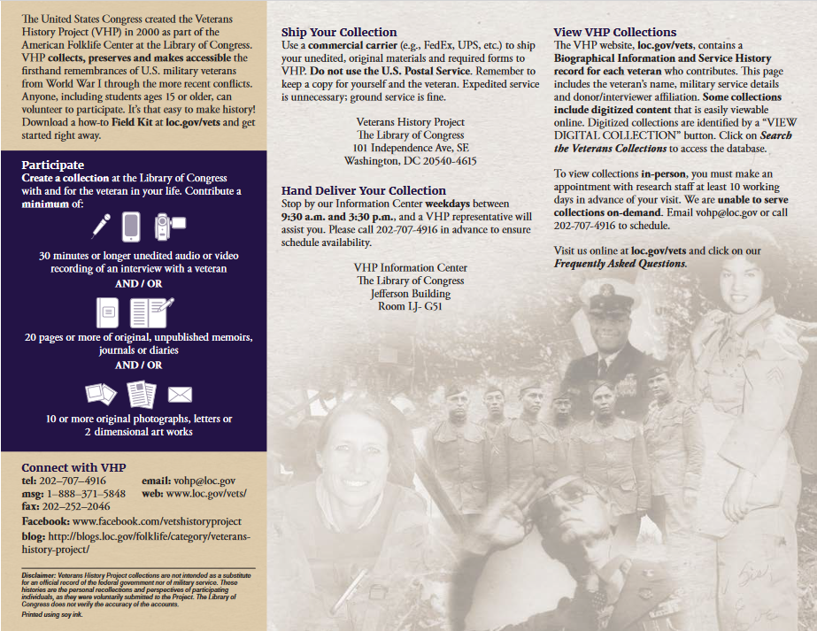

**Department Officer’s Visit Form**

Please return this form as soon as possible after a Department Officer has visited your Unit to:

Department Historian, Dayna Beyer, 6013 Garber Rd., Bellville, Ohio 44813

Unit # __________ Unit Name ________________________________________________________________

Unit Historian’s Name:_______________________________________________________________________

Date of Officer Visit: ________________________________________________________________________

Title of Officer: ____________________________________________________________________________

Name of Officer: ___________________________________________________________________________

Briefly, what events did the officer attend while visiting your Unit?

____________________________________________________________________________________

____________________________________________________________________________________

____________________________________________________________________________________

Were junior members involved or attending function? Yes _______ No _______

Were any significant gifts presented to the officer in attendance? Yes _______ No _______

Please provide any other details for the Ohio Department History for 2021- 2022 below.

____________________________________________________________________________________

____________________________________________________________________________________

____________________________________________________________________________________

____________________________________________________________________________________

____________________________________________________________________________________

You may send in a picture or two with this entry, and please make a copy to keep for your Unit History. We wish you a successful year with great stories to share.